**Synapse Analytics**

**Capabilities for Exploratory environment**

1. Data
   1. Configure linked services (Preview data , schema - Json format , csv etc)
   2. Realtime Streaming data – Synapse Link for Cosmos DB
   3. Custom Data Connectors /activity
2. File formats supported – structured, unstructured
3. Explore data in data source
   1. Select top
   2. SQL on demand
   3. Open rowset
   4. Bulk load
   5. Load data with spark notebook
4. Coding experience
   1. Import / Export / Clone
   2. Integration with Visual Studio, SSMS, Synapse workspace
   3. Debug
   4. Process execution status
   5. Schedule in the Runtime environment/ Trigger
   6. Future roadmap –
      1. CI/CD - DevOps / Git enabled in future (already available in Data Factory)
      2. Python Kernel
      3. Auto ML: No-code experience
5. Data Manipulation
   1. SQL
   2. Spark code
   3. ETL with Data Factory (No-code, Low-code)
   4. Virtual Datawarehouse
6. SQL capabilities
   1. Ansi SQL
   2. On- Demand SQL
   3. CETAS
   4. Materialized views
   5. Result-set caching
7. Spark capabilities
   1. Create a spark notebook for the SQL table read
   2. Python libraries for modeling
   3. Auto ML
   4. ONNX – to move the model across different platforms
   5. Time travel for delta lake using spark
8. Data Factory
   1. Reading a data source
   2. Orchestration- pipelines and execution
9. Power BI
   1. Connect to a PBI workspace and develop insights/visualizations
10. Security
    1. Managed VNets
    2. IP firewall rules
    3. Endpoint
    4. Threat detection
    5. Row Level security
    6. Column level security
    7. Dynamic data masking
    8. Transparent Data Encryption
    9. Synapse Roles – Workspace admin, sql admin, spark admin

*Active directory / single sign on

*Underlying access permissions for the data lake

1. SQL Server management features – Transparent Data Encryption, Activity logs (identify the sql statements executed), Monitoring Query activity, Geobackup, Maintenance Schedule
2. Spark management features – Monitoring, Activity logs, metrics; Package config file
3. SQL Distribution
   1. HASH distributed
   2. Round Robin
   3. Replicated
   4. Index
      1. Clustered Columnstore Index
      2. Clustered Index
      3. Heap
      4. Nonclustered indexes
      5. Ordered Clustered Columnstore Index
4. Pricing
   1. Synapse workspace creation: It should not cost anything.
   2. Spark Pool Pricing
      1. No Auto Scale /Auto Scale
      2. AutoPause
   3. SQL Pool Pricing:
      1. Pool compute
         1. DWU = DTU * 7.5
         2. cDWU = DTU * 9
   4. On demand SQL pricing : Query Scenario calculation
      1. 30 execution times /month; 0.5 TB per execution times

Calculation : 30 * 0.5 * 6.75 = $101.25 (Monthly cost))

(On Demand SQL + Create External table is a cost efficient way to read big data and Extract/Summary needed data to SQL tables.)

**File formats supported**

|  |  |  |  |  |  |  |  |  |  |
| --- | --- | --- | --- | --- | --- | --- | --- | --- | --- |
|  | Preview | SQL Openrowset | SQL External table | Sql Copy | Spark notebook | DataFactory | Custom code |  |  |
| Parquet |  | Checkmark | Checkmark | Checkmark | Checkmark | Checkmark | Checkmark |  |  |
| CSV | Checkmark |  |  |  | Checkmark | Checkmark | Checkmark |  |  |
| Json | Checkmark |  |  |  | Checkmark | Checkmark | Checkmark |  |  |
| XML | Checkmark |  |  |  |  | Checkmark | Checkmark |  |  |
| Avro |  |  |  |  |  |  | Checkmark |  |  |
| SQL tables |  |  |  |  | Checkmark | Checkmark | Checkmark |  |  |

**Demo :**

Synapse workspace creation: 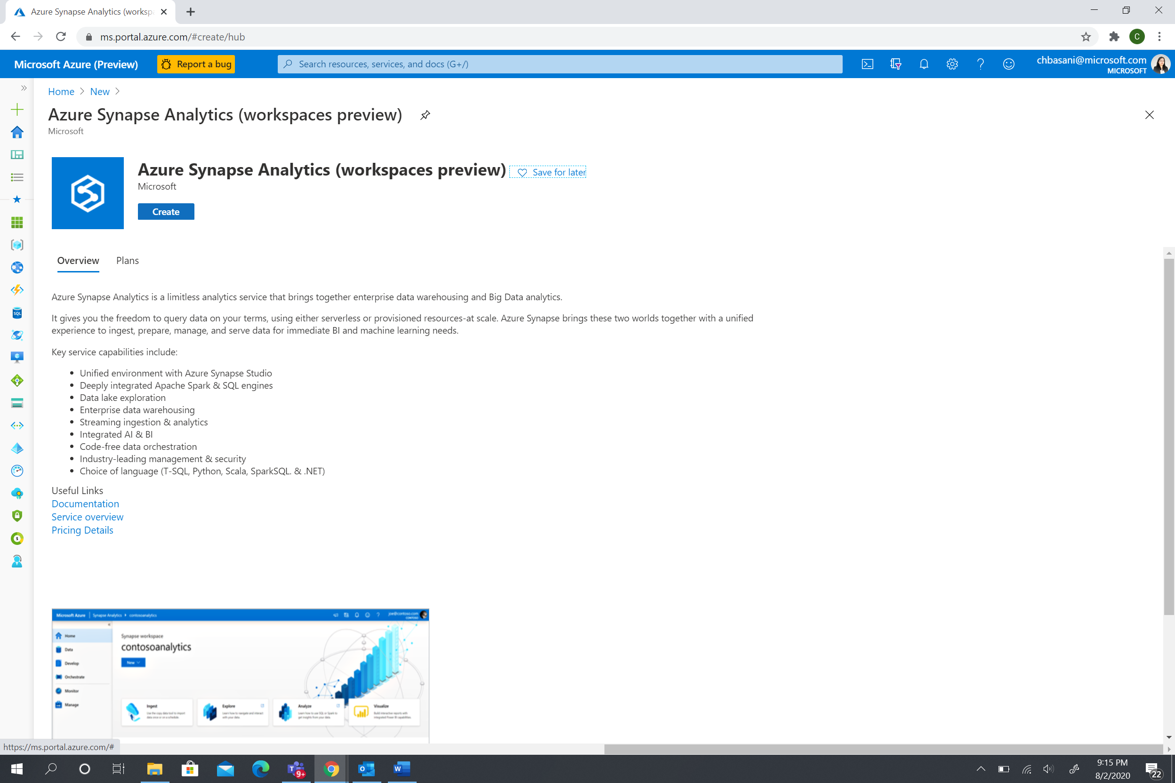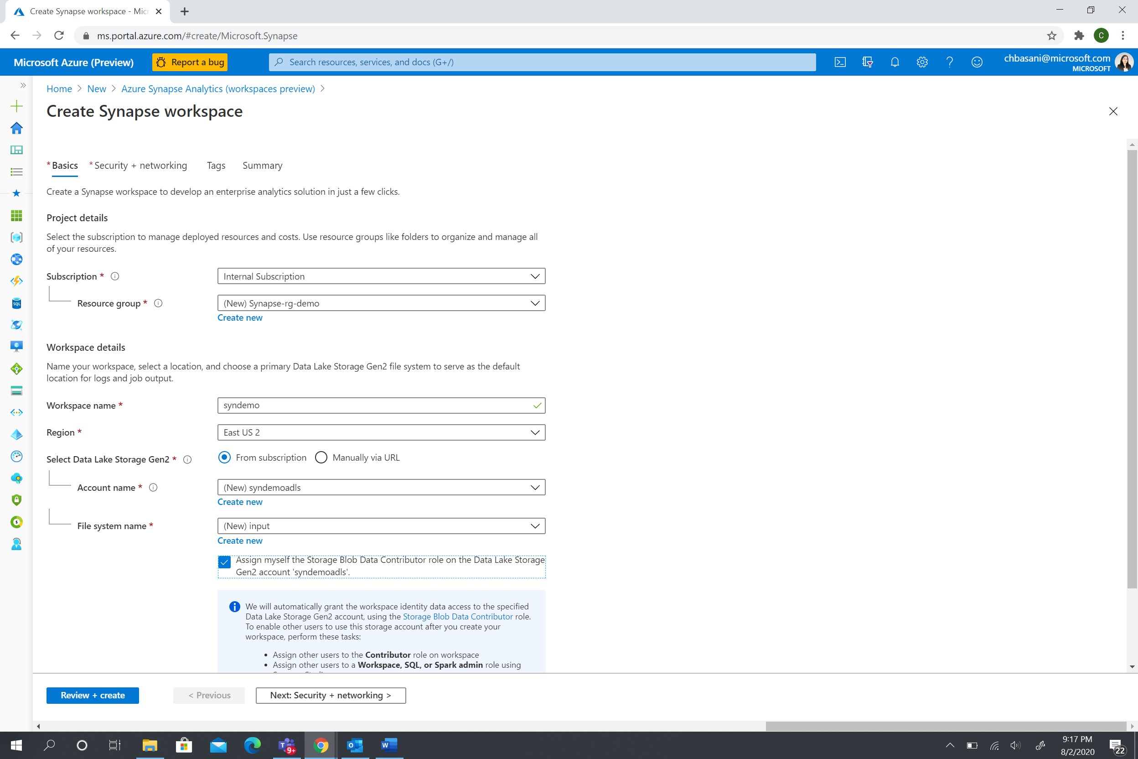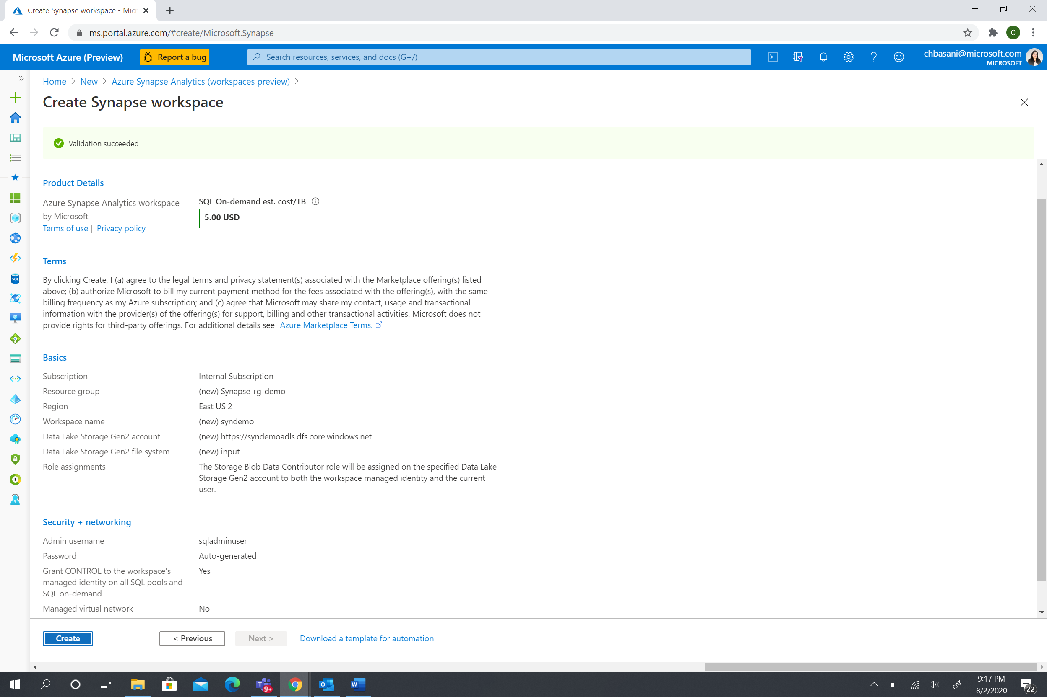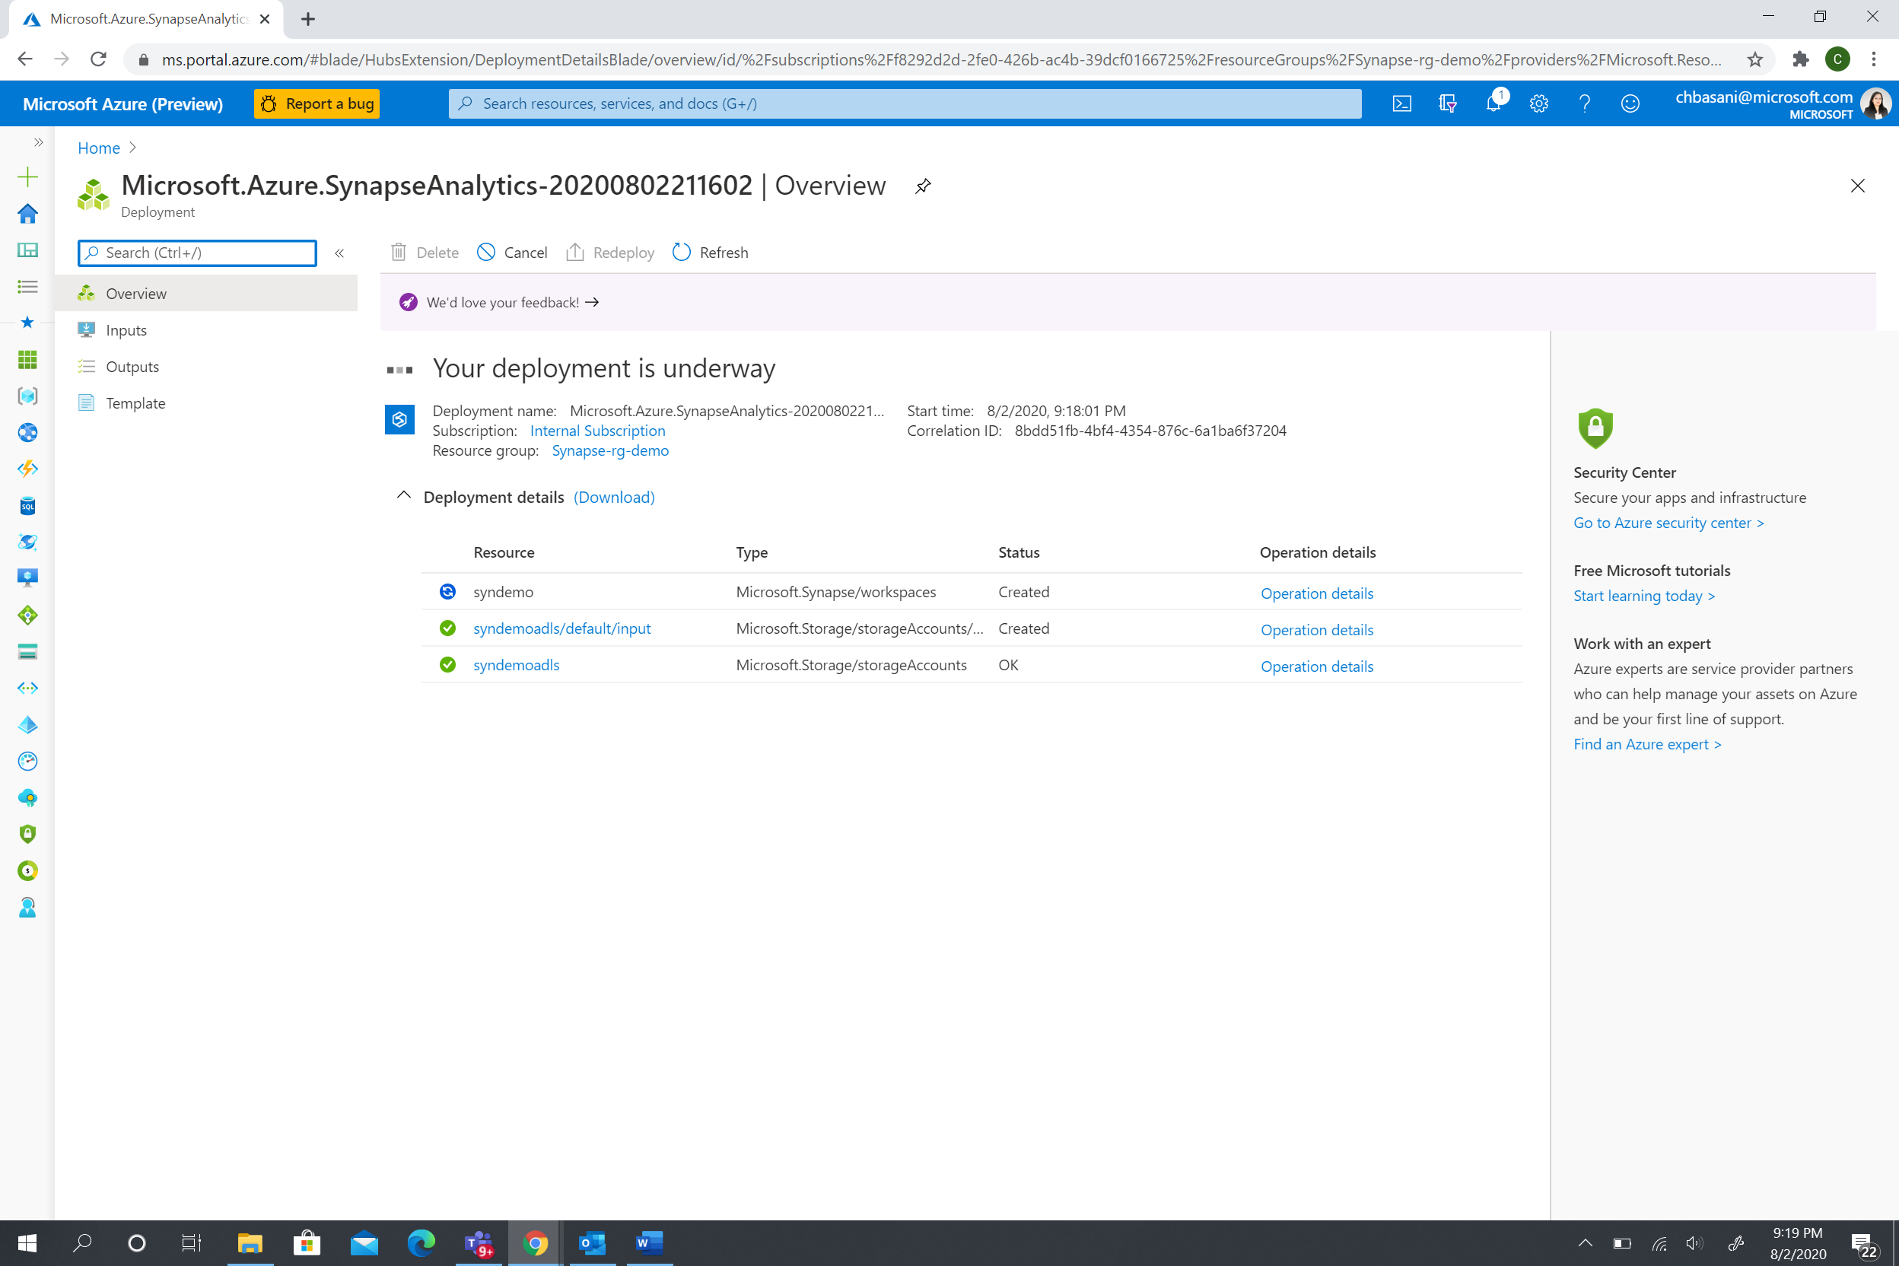

Click on the data lake in the resources being deployed: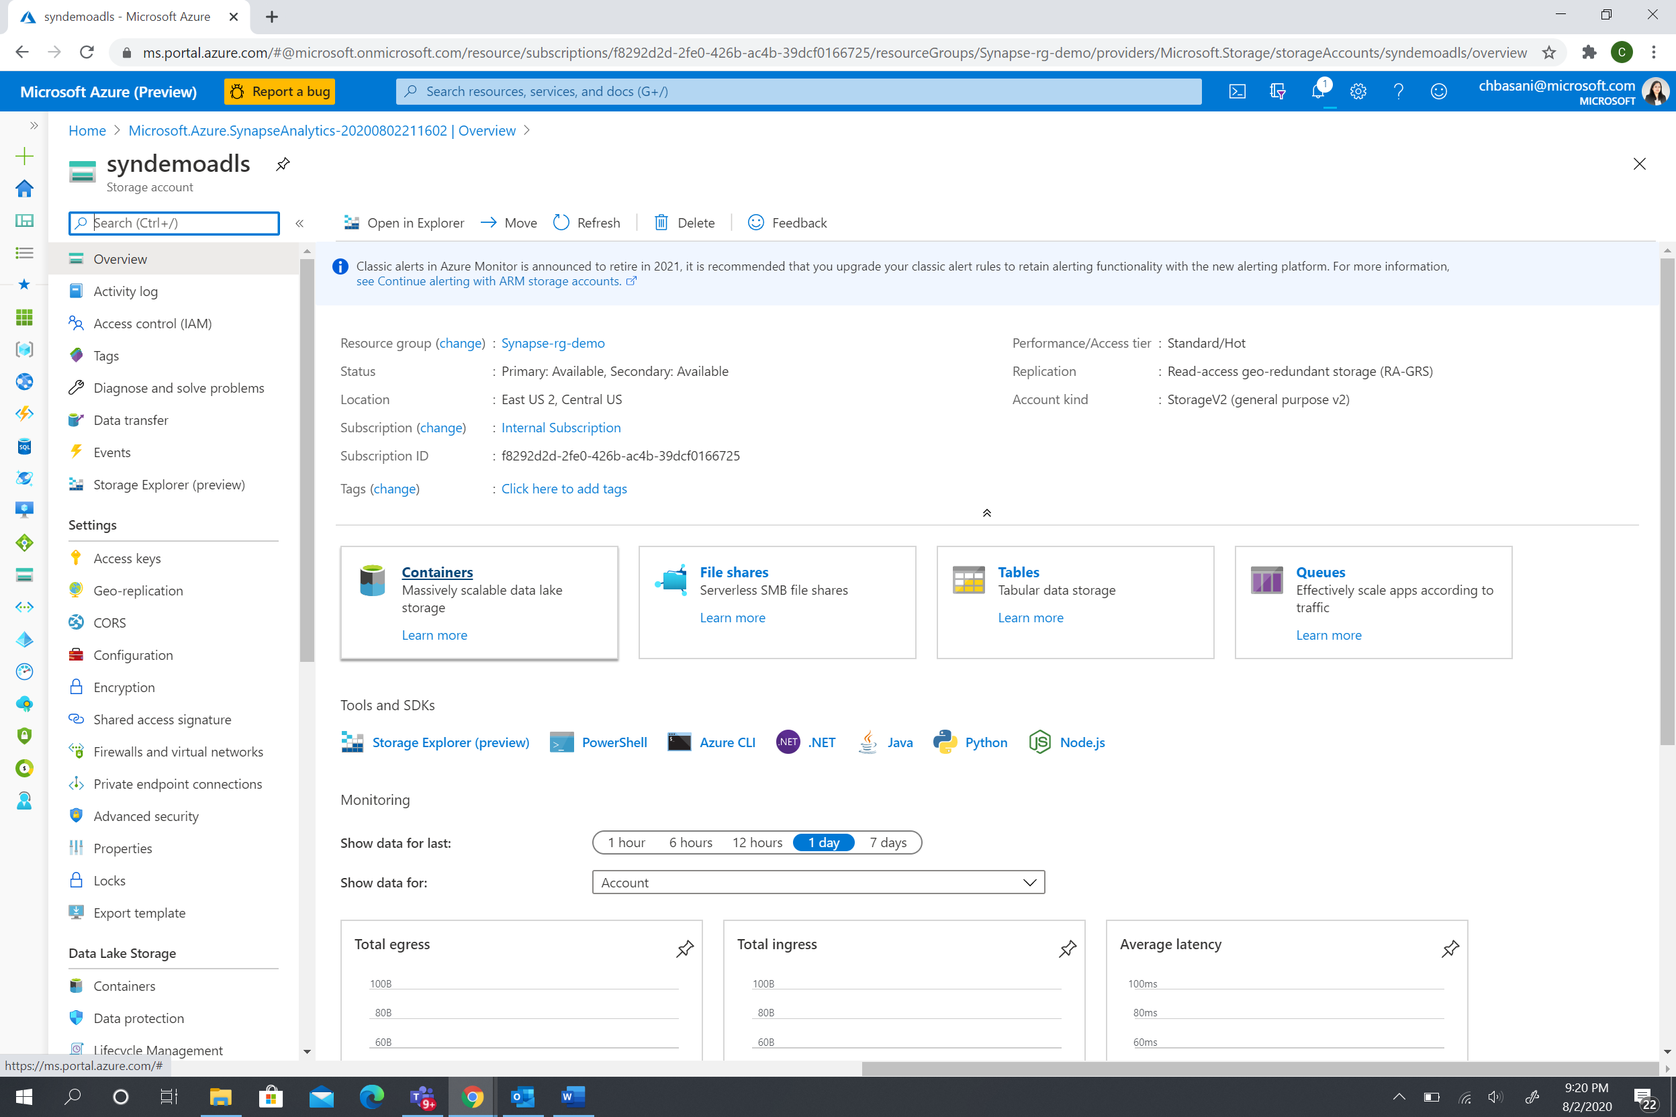

Create containers with the following names:

1.txtfiles

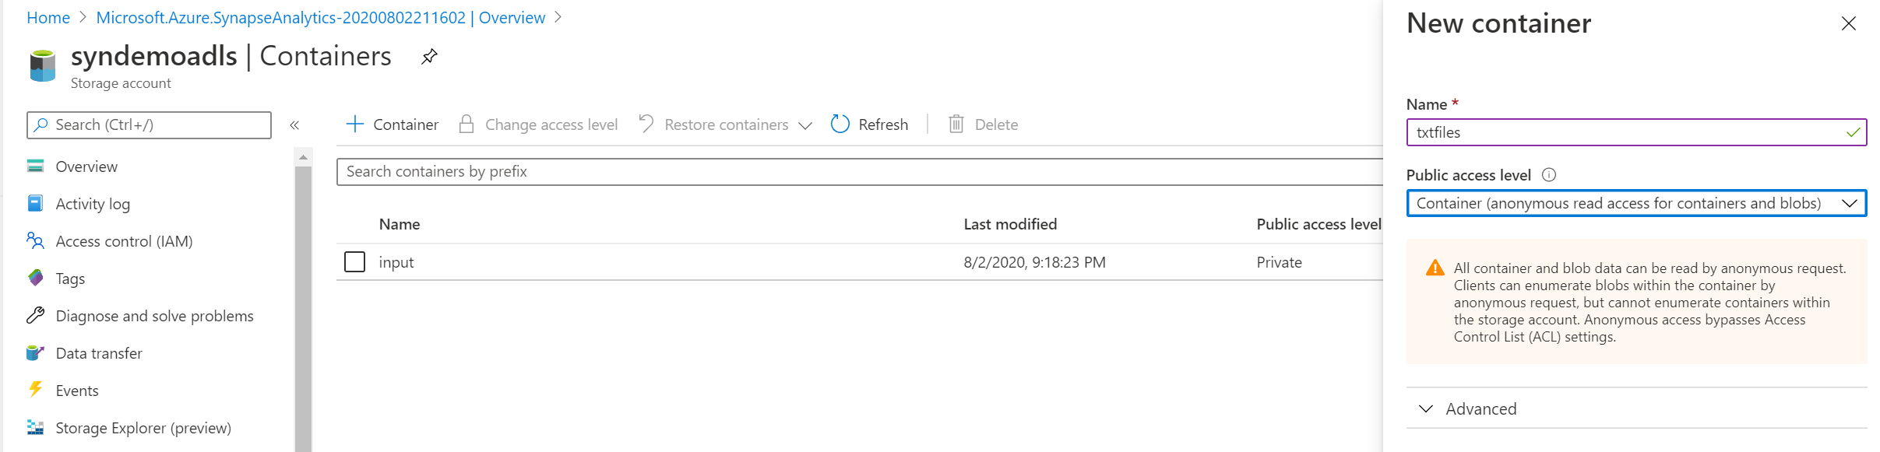

2.parquetfiles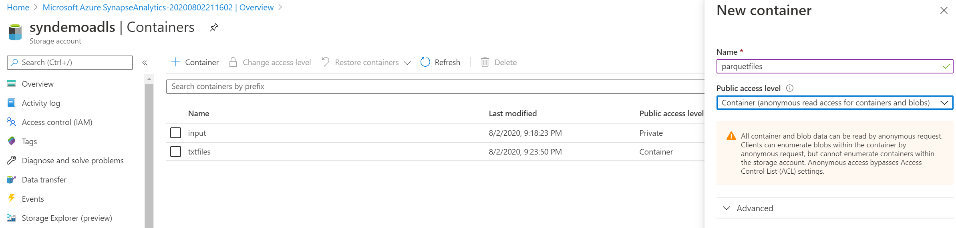

3.jsonfiles

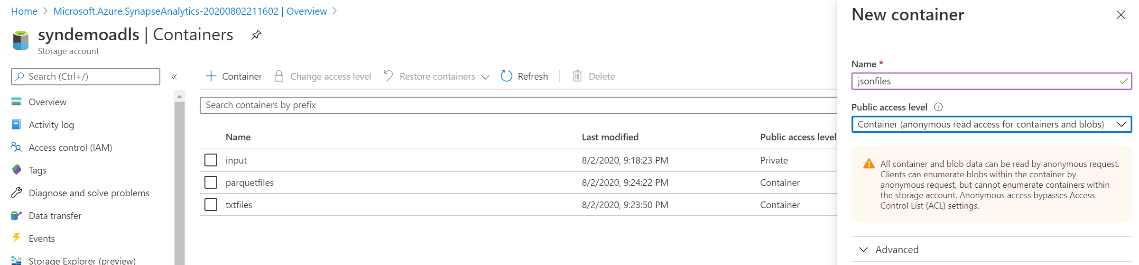

4.xmlfiles

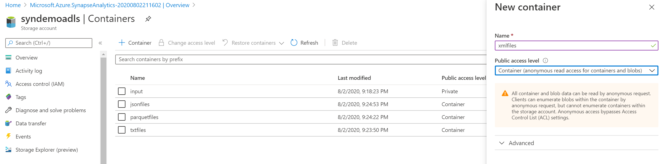

5.output

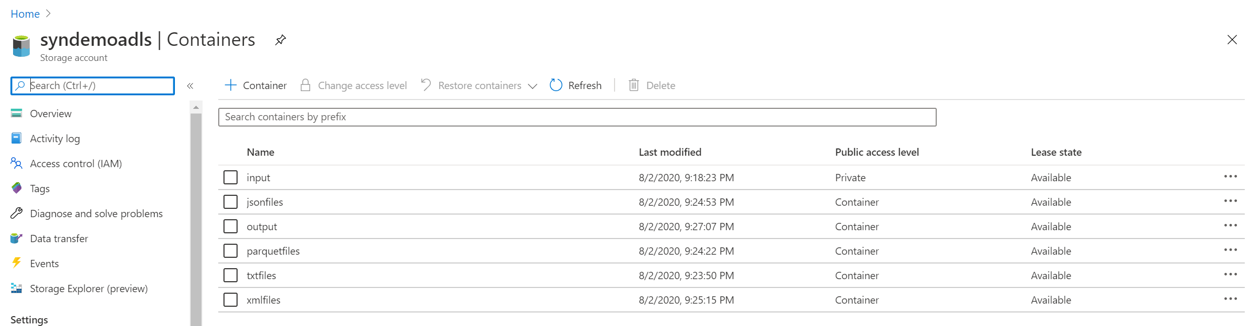

Synapse workspace :

In the resource group : 

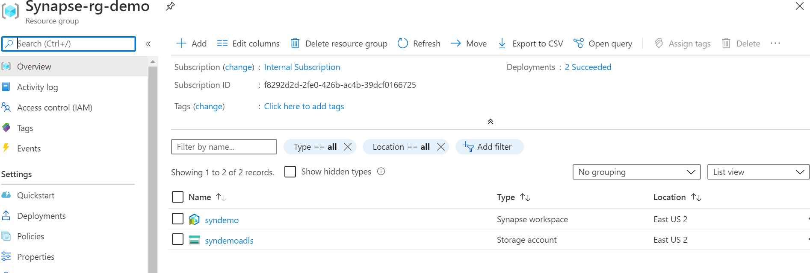

Click the Synapse workspace resource and Launch workspace using the Workspace web URL:

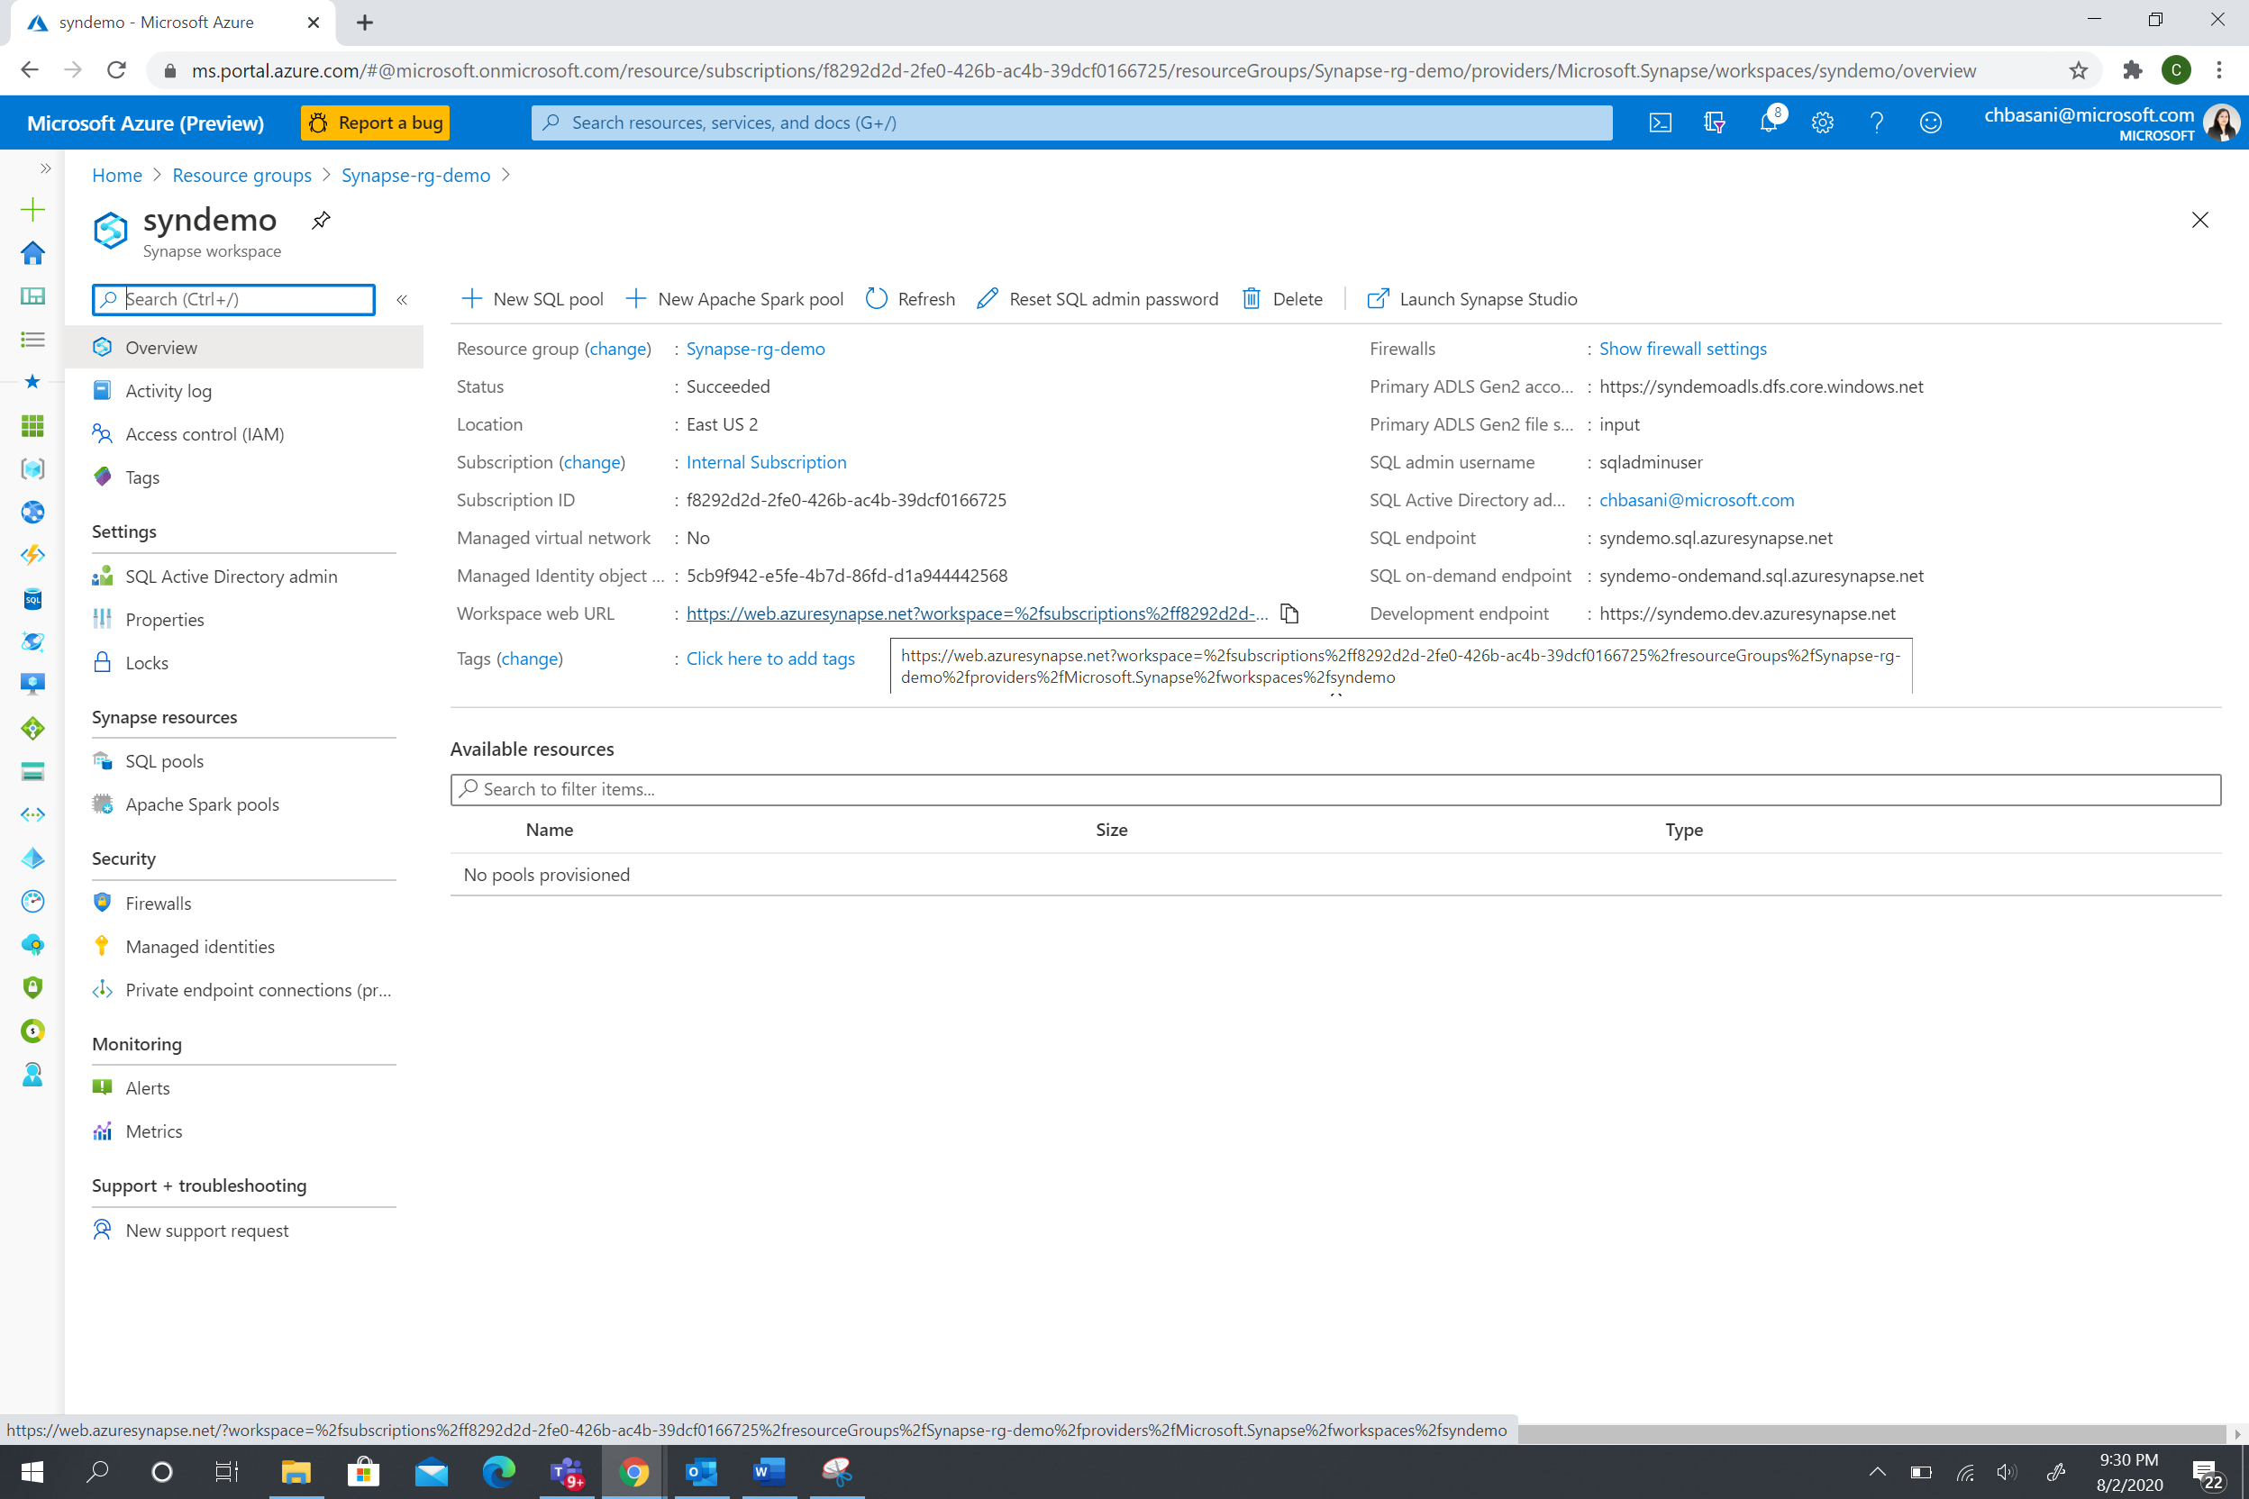

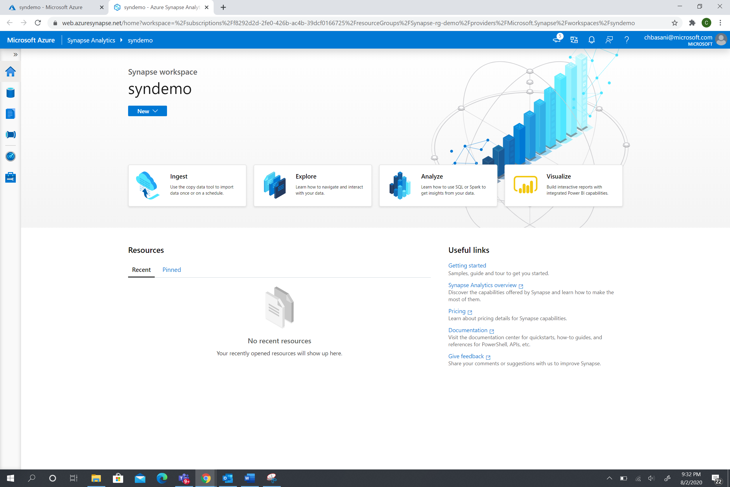

Click the Data Hub : There are 2 parts

1.Workspace

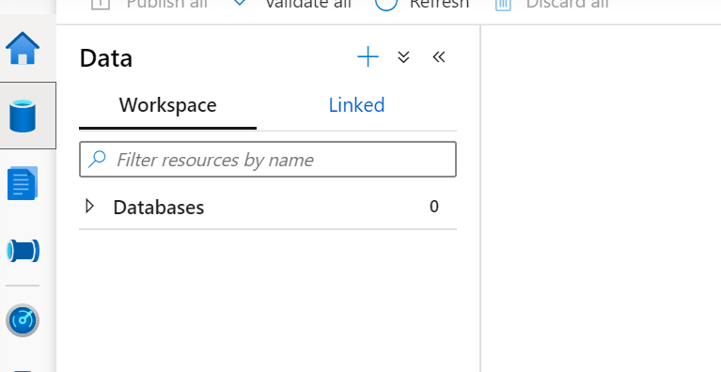

The workspace has all the databases listed.

1. As we create the On-demand resources, the tables /views / external tables etc are shown as a list in the view.
2. As we launch a SQL Pool , it will be under the databases .
3. As we create a table in the spark pool, it will be displayed as the Spark datasets.

2.Linked services:

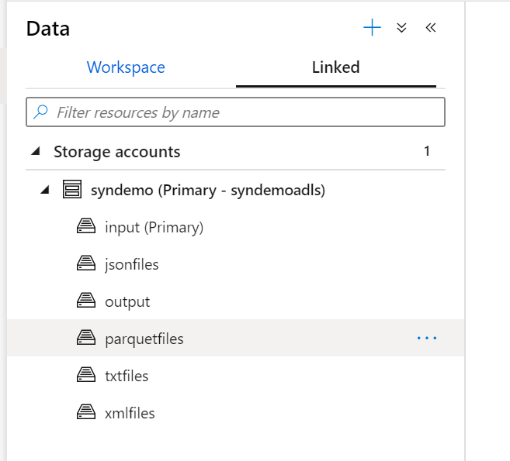

The Linked services has a) Storage accounts b)Datasets

Already has the datalake, which is the foundation for the workspace. The container that we defined in the workspace creation is marked as the Primary .

As we create a dataset in data factory, it will be listed under the Datasets in the view.

If there are more linked services created to a SAP , Amazon , Oracle resources , they will be listed in this view.

It is a no code environment for the predefined set of 80+ connectors.

**Data Exploration:**

* Click on the container and explore the files.
* Click on parquet folder -> click upload button. And upload the parquet file

part-00000-snappy (1).parquet

* Click corresponding folders - >click upload button and upload the below files into respective containers

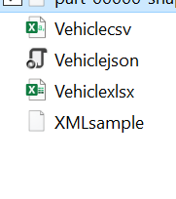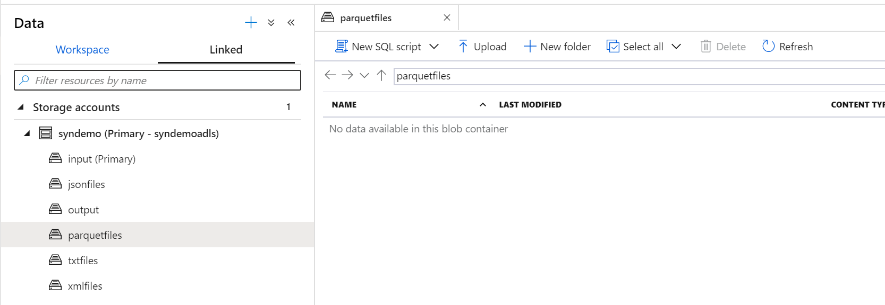

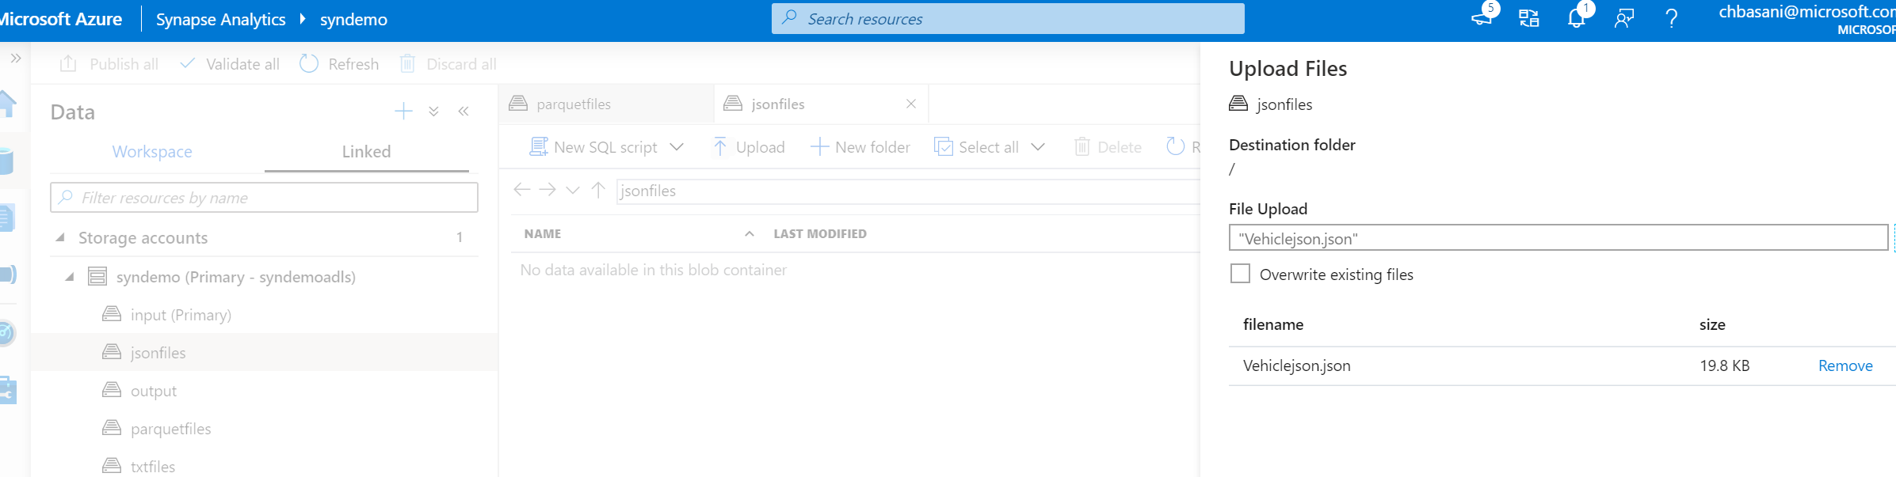

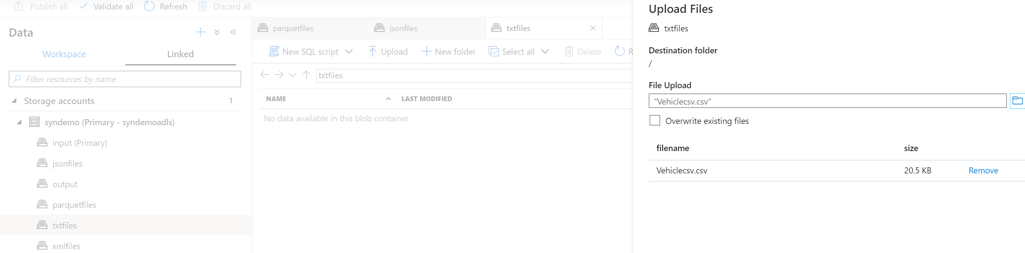

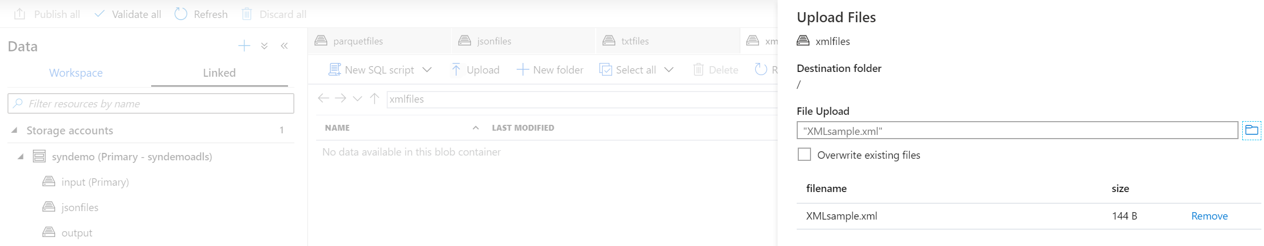

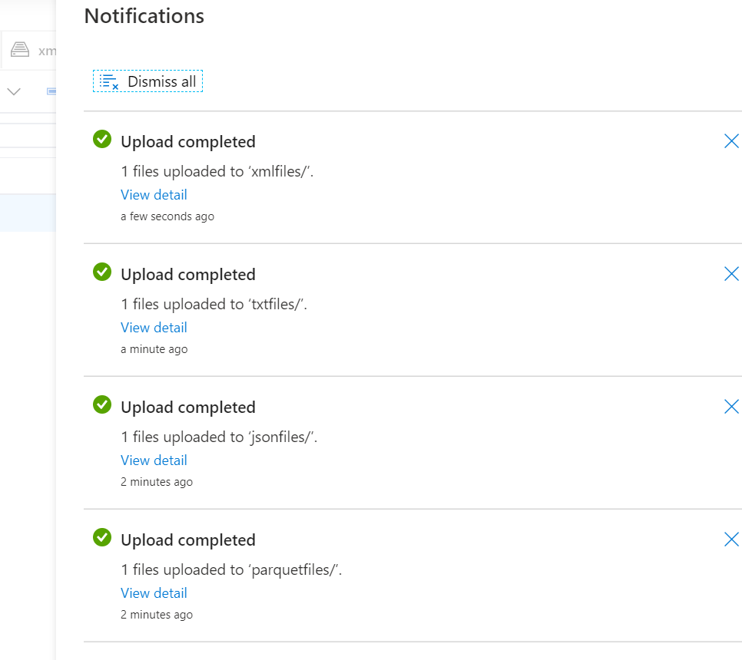

* Preview feature for the files in the datalake :

Right click on Json files or CSV files to preview the file .

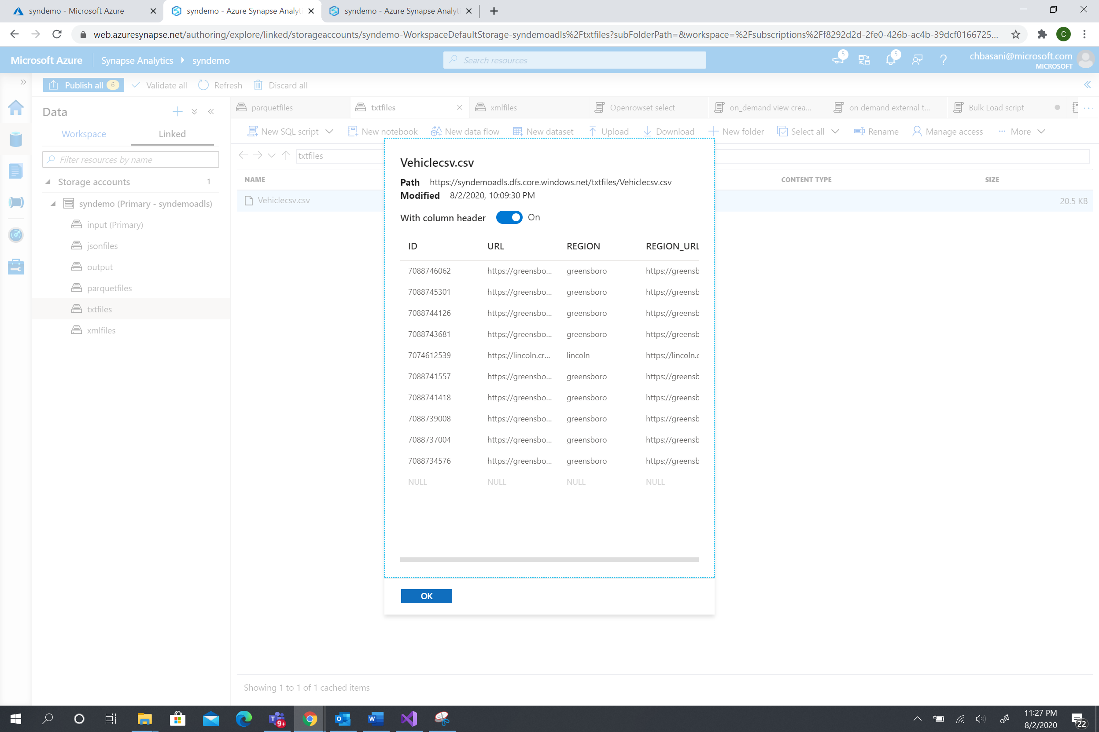

**Data access:**

For parquet file:

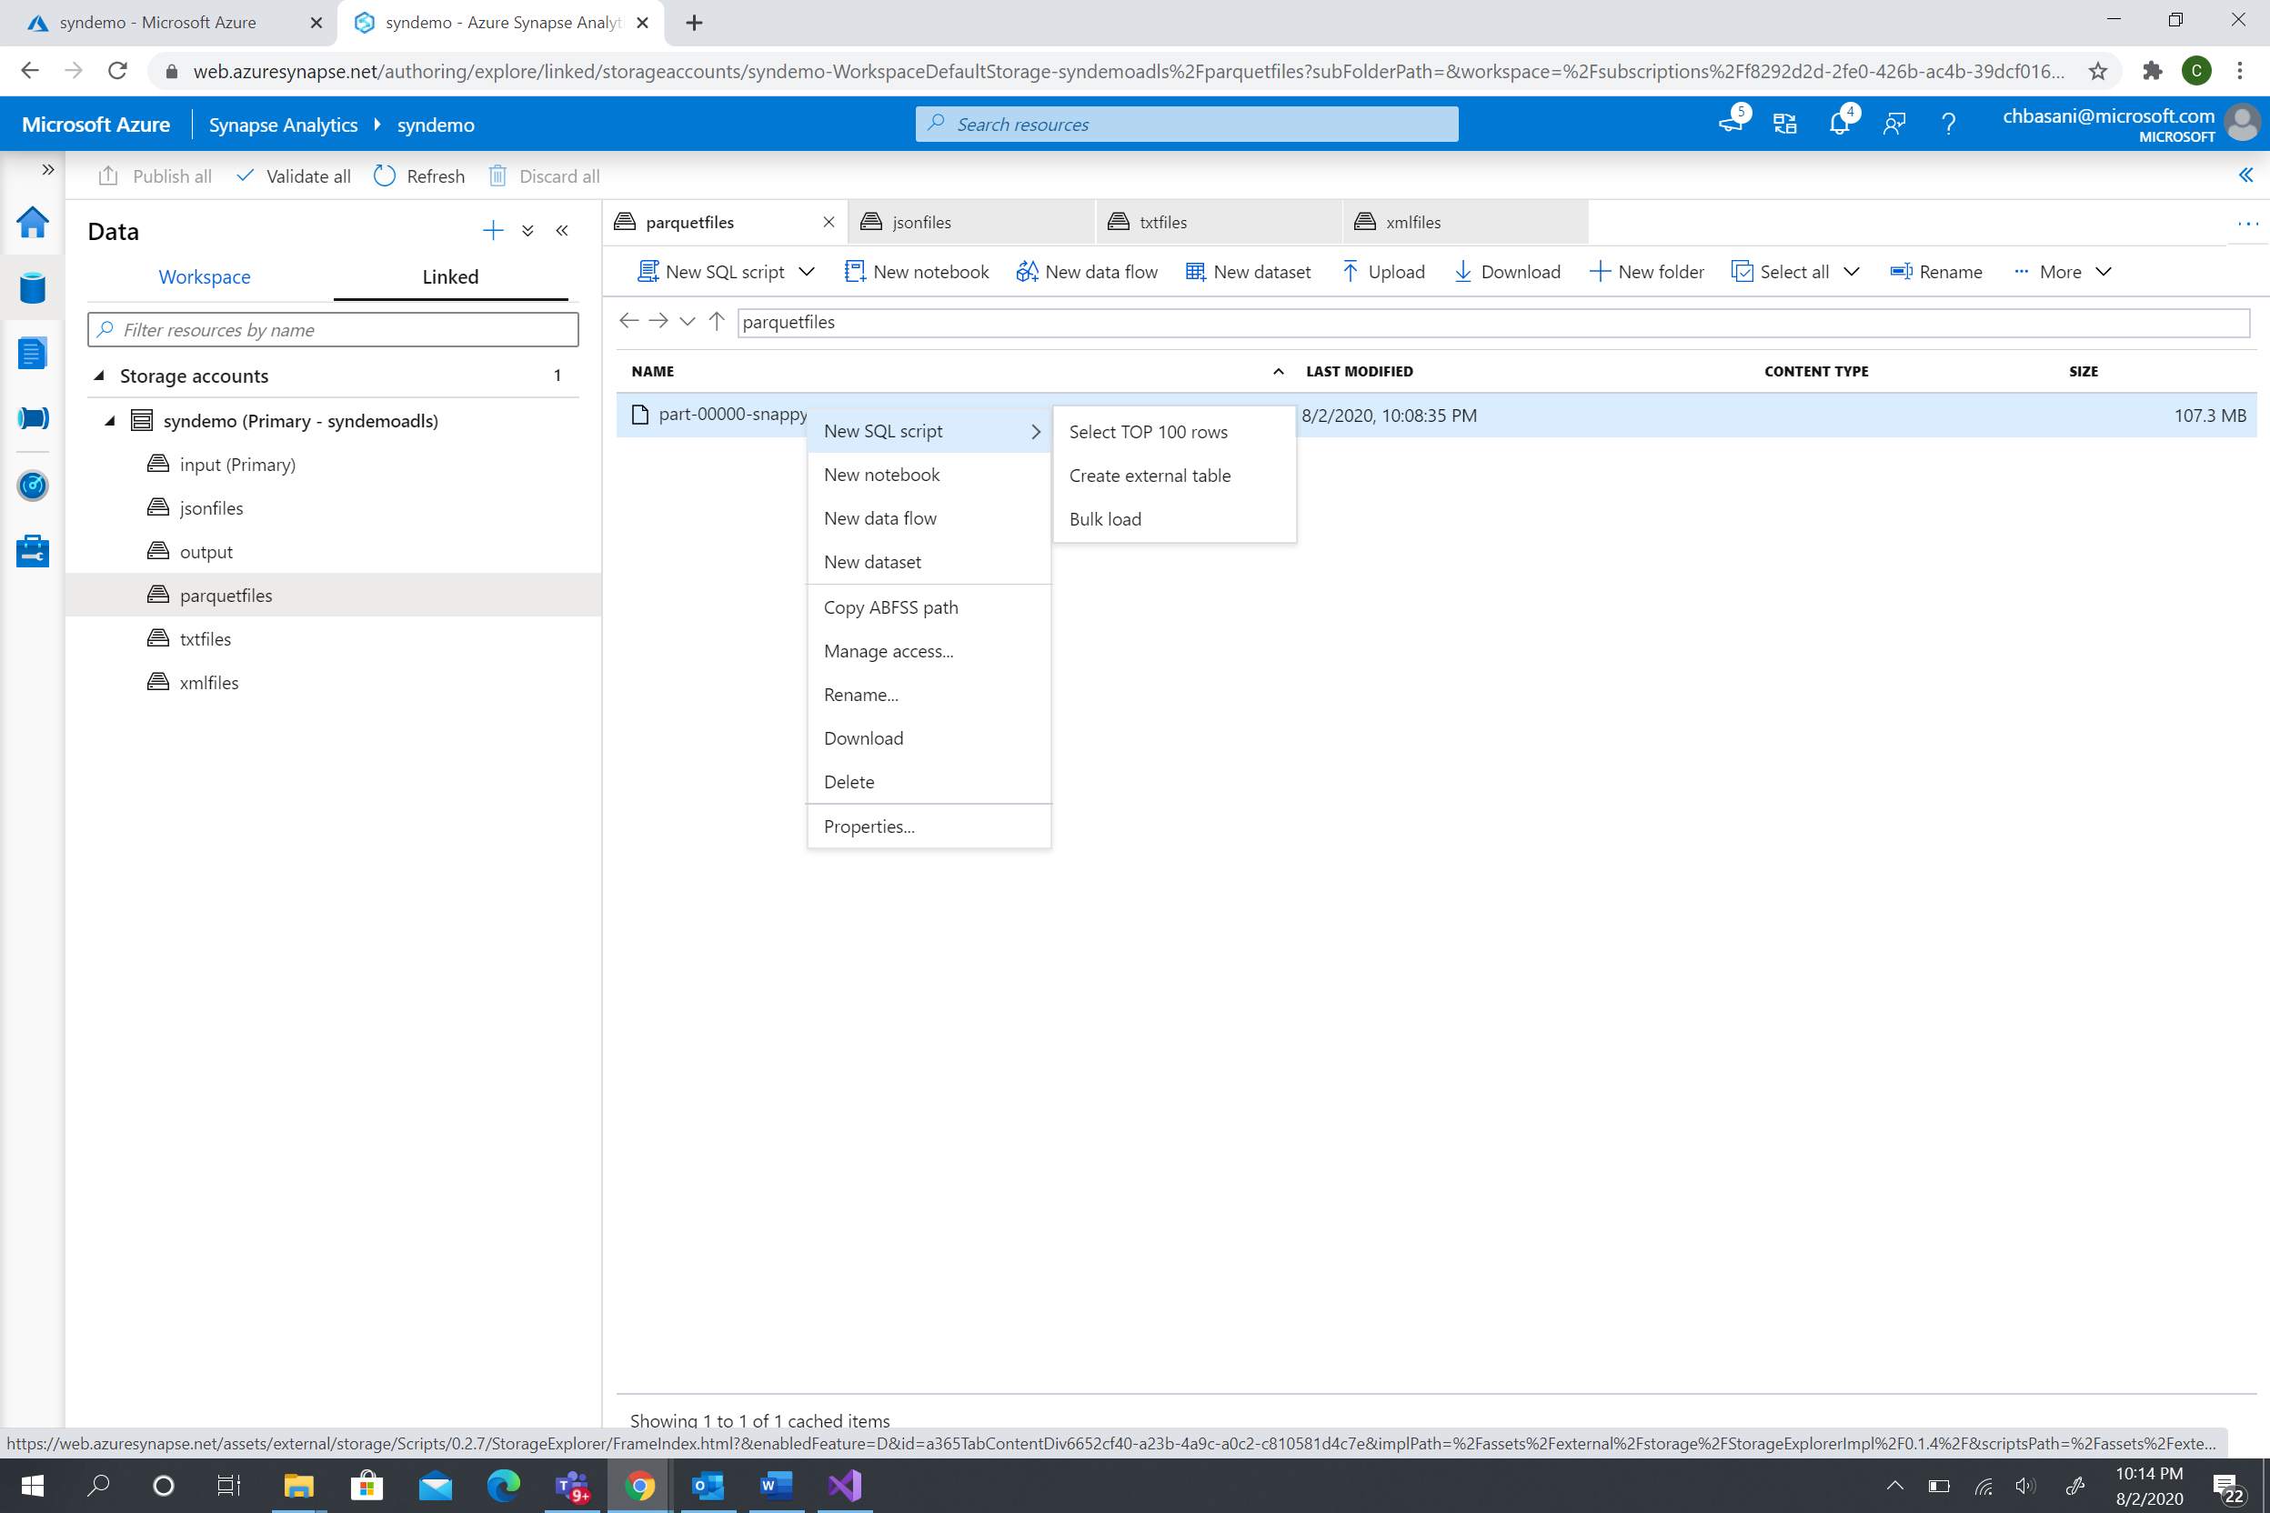

Open rowset:

Right click parquet file-> click on the New SQL script - > Select Top 100 rows

Open rowset can be executed on the SQL on-demand . It has all the information about the file location.

Click run to execute the generated script.

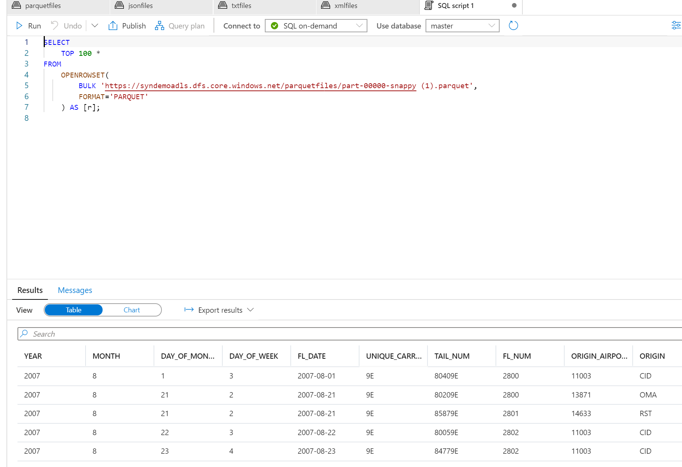

Create Views with on-demand pool:

1. Development hub -> New SQL script -> Copy paste the code

-- type your sql script here, we now have intellisense

create DATABASE on_demand_db;

use on_demand_db;

create view flightview

as

SELECT

    TOP 100 *

FROM

    OPENROWSET(

        BULK 'https://syndemoadls.dfs.core.windows.net/parquetfiles/part-00000-snappy (1).parquet',

        FORMAT='PARQUET'

    ) AS [r];

select * from flightview

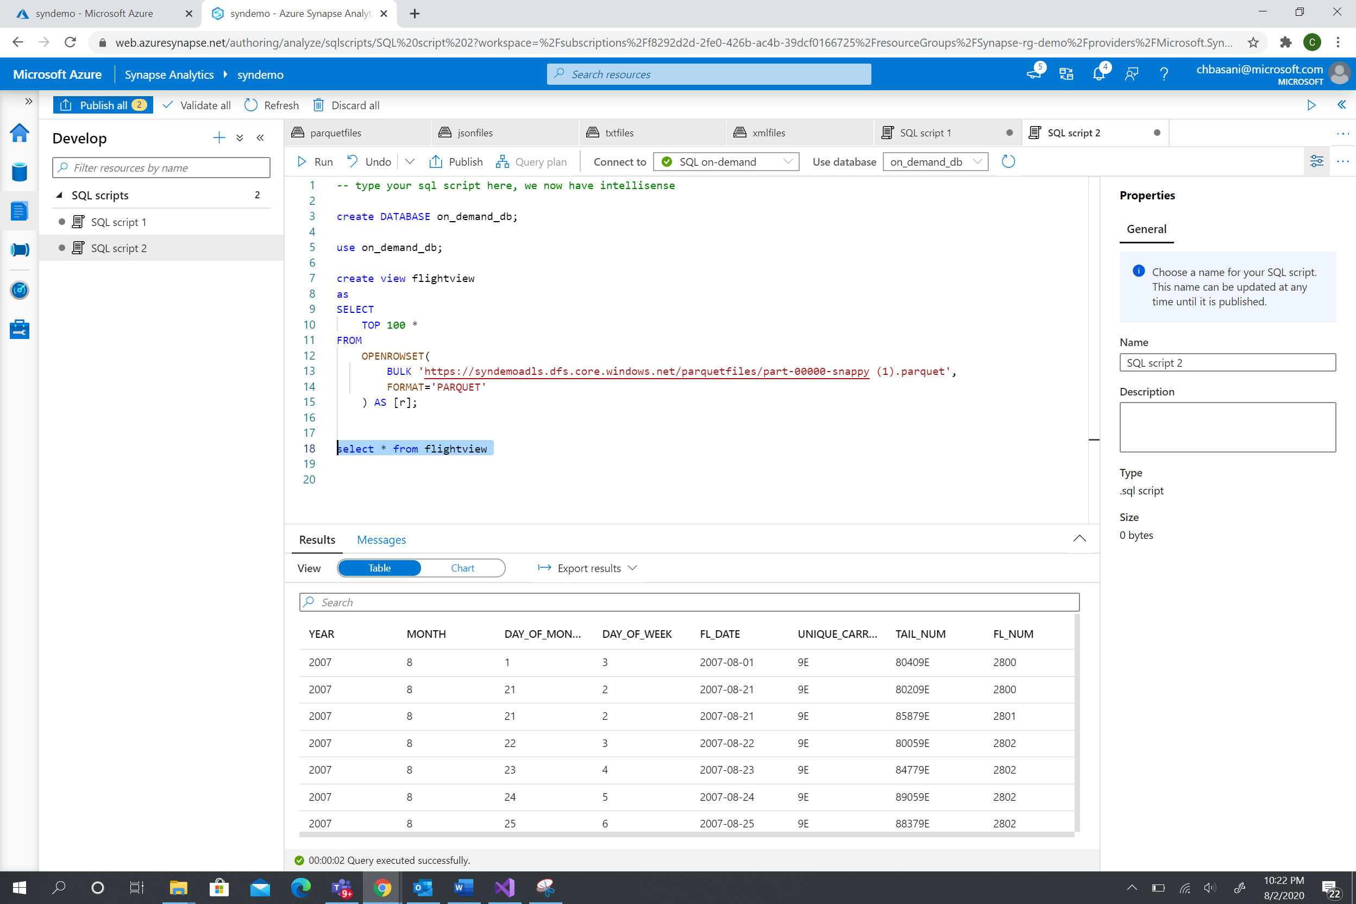

The view is created and listed in the Data hub -> Data bases -> on_demand_db-> Views -> db.flightview

*Make sure the use database drop down has the newly created database in the on-demand pool.

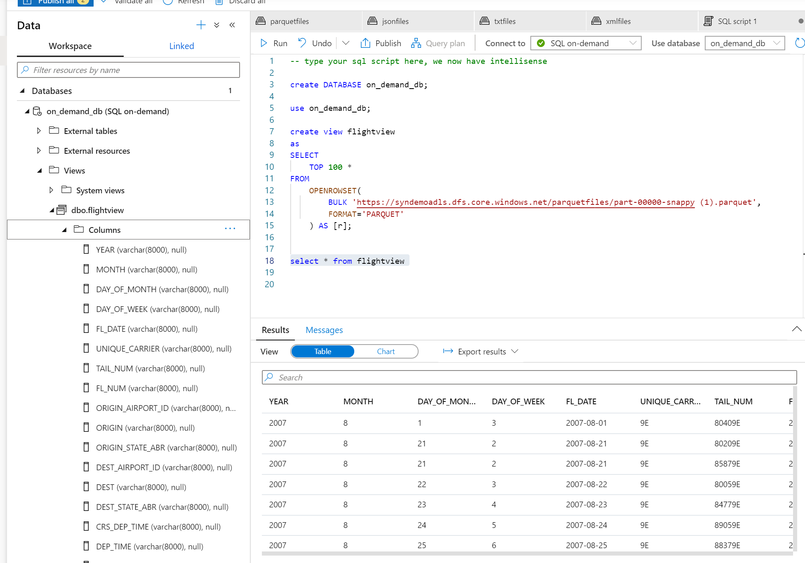

The view can be used as a normal database view in exploration/select/filter.

Create external table in On-demand sql pool:

Right click the parquet file and select external table

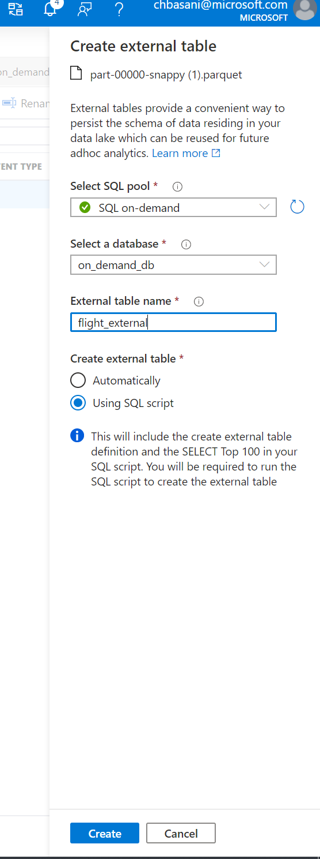

Run the code . You can access the external file data source with a overlayed database metadata.

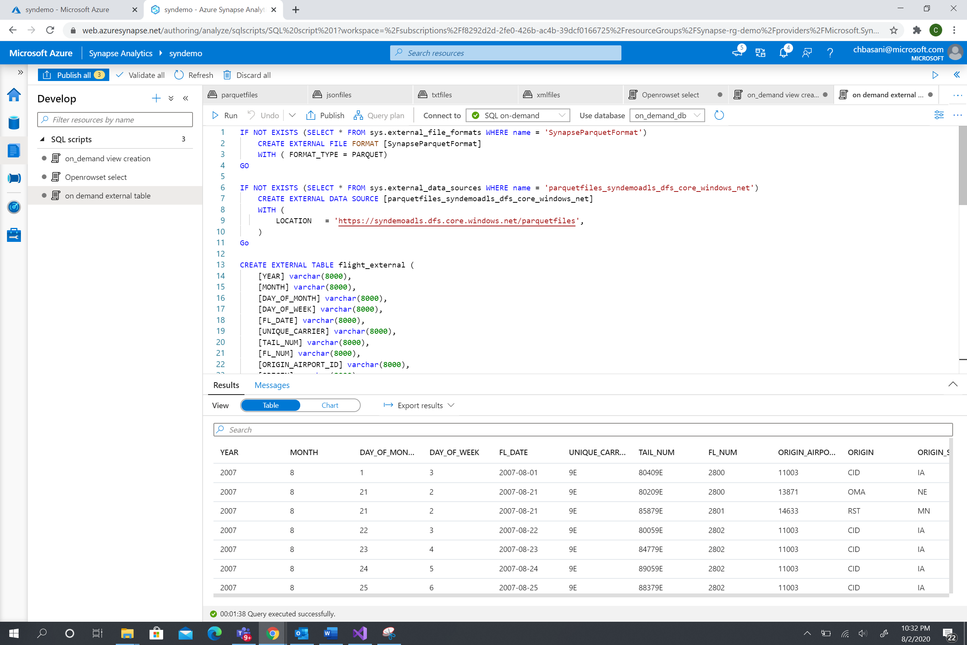

*Bulk load: (Enabled for Parquet and csv files ) .

It needs the SQL pool to be created. It loads the files to the SQL pool for future use.

The latency is low on the curated files loaded into the SQL pool.

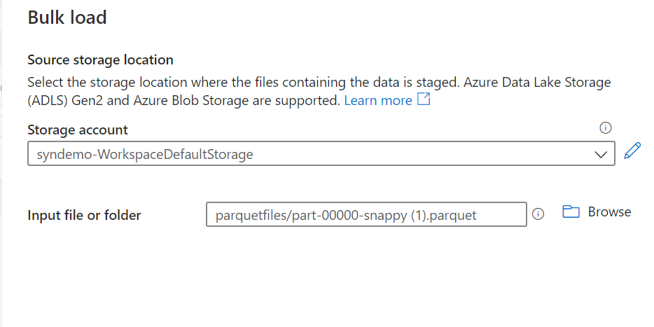

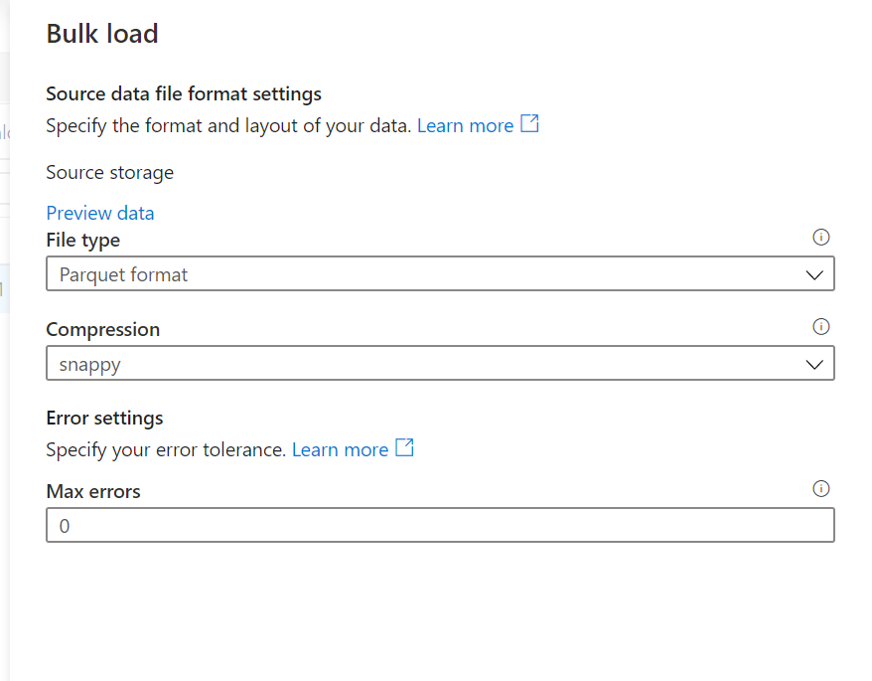

It will detect Schema . Click continue

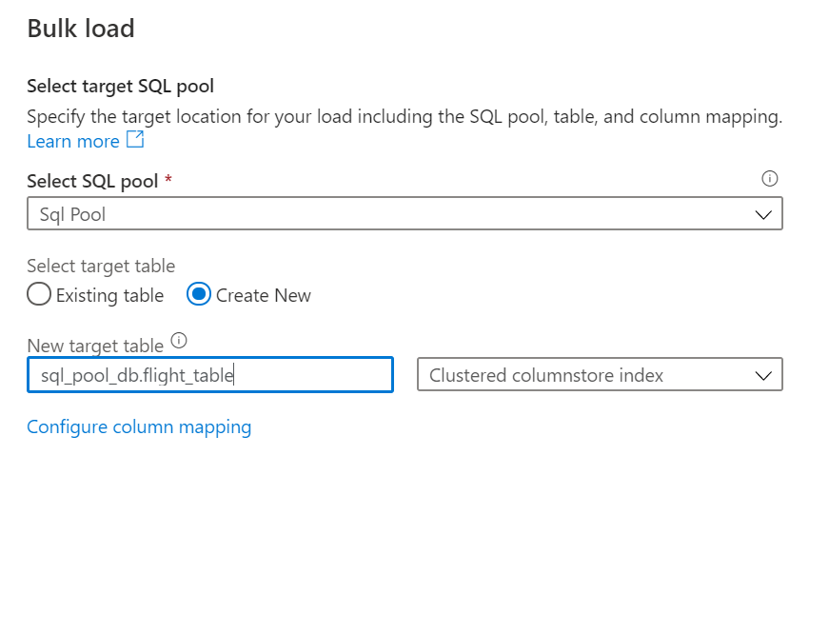

Enter name of the target table as flight_table

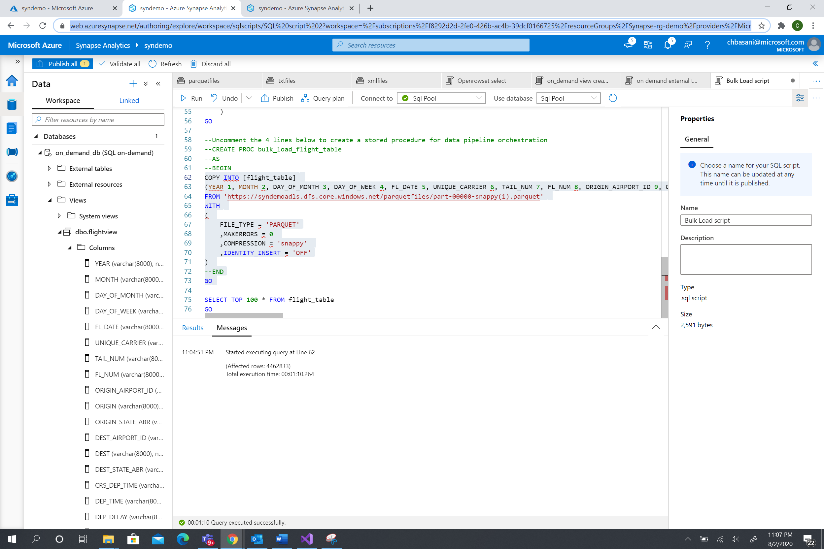

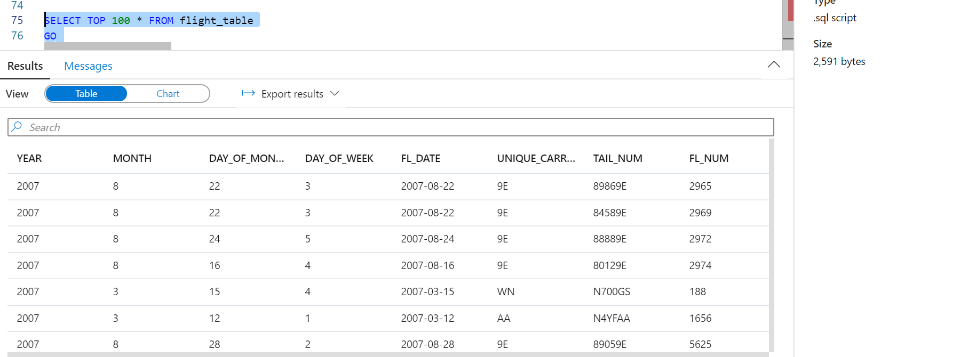

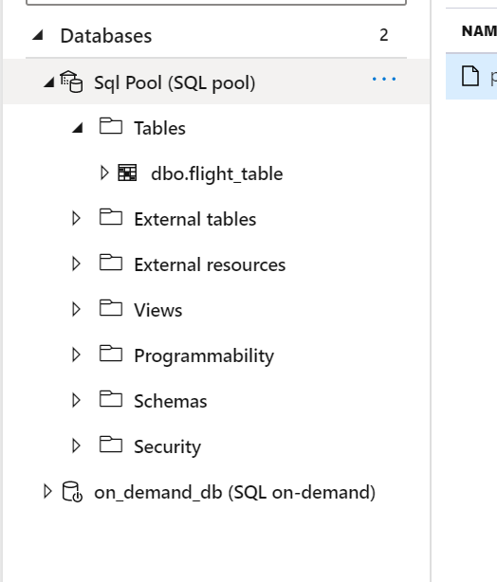

Spark codes for different file types:

1 . For the parquet file , Right click -> the New notebook .

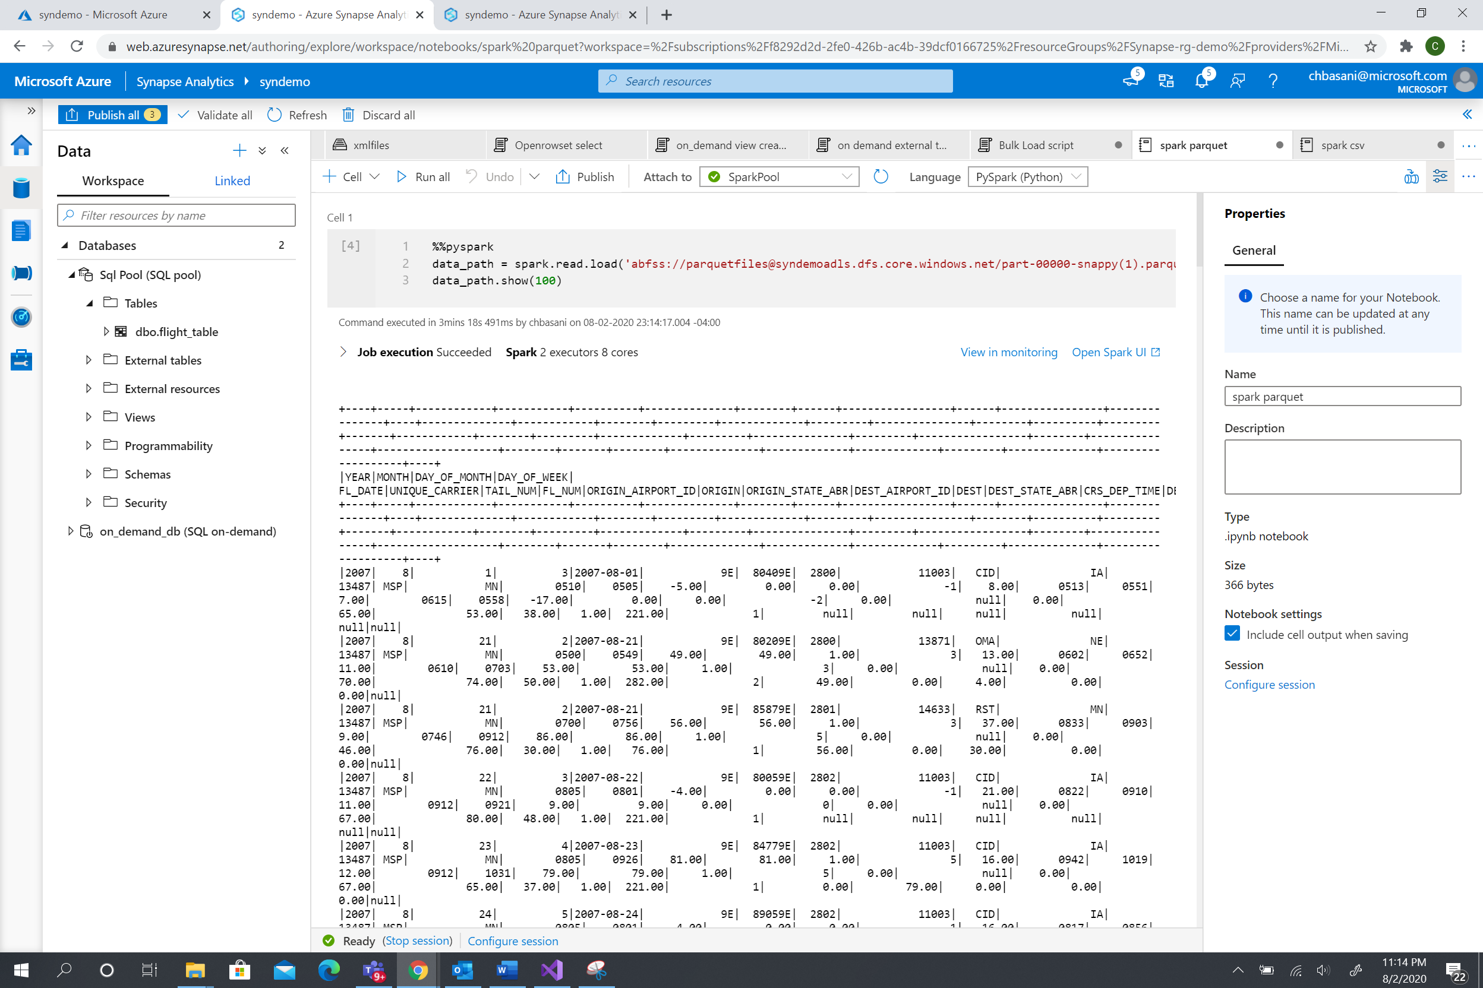

1. For csv files, right click -> New notebook

file has the first row as header, uncomment the line” header=True “

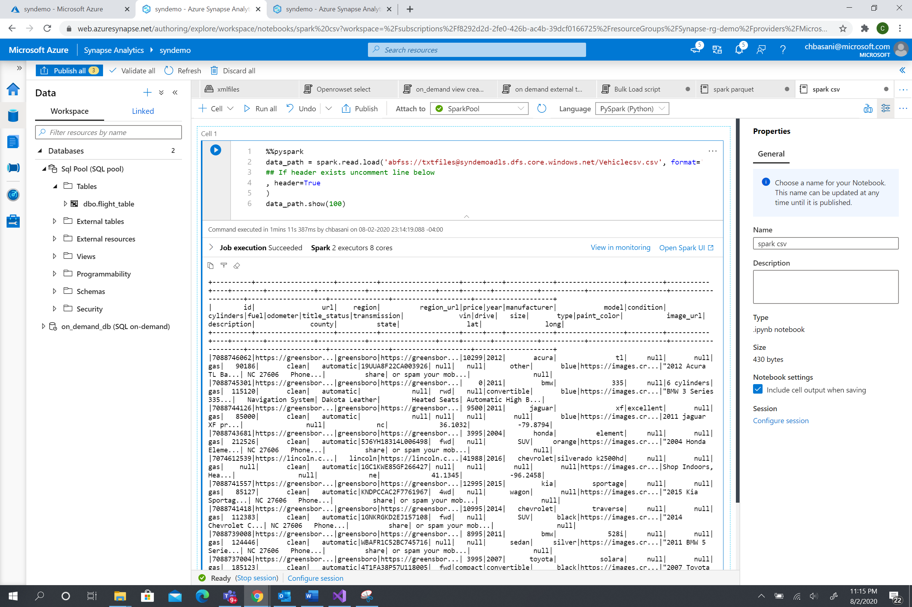

1. For Json , file use the code 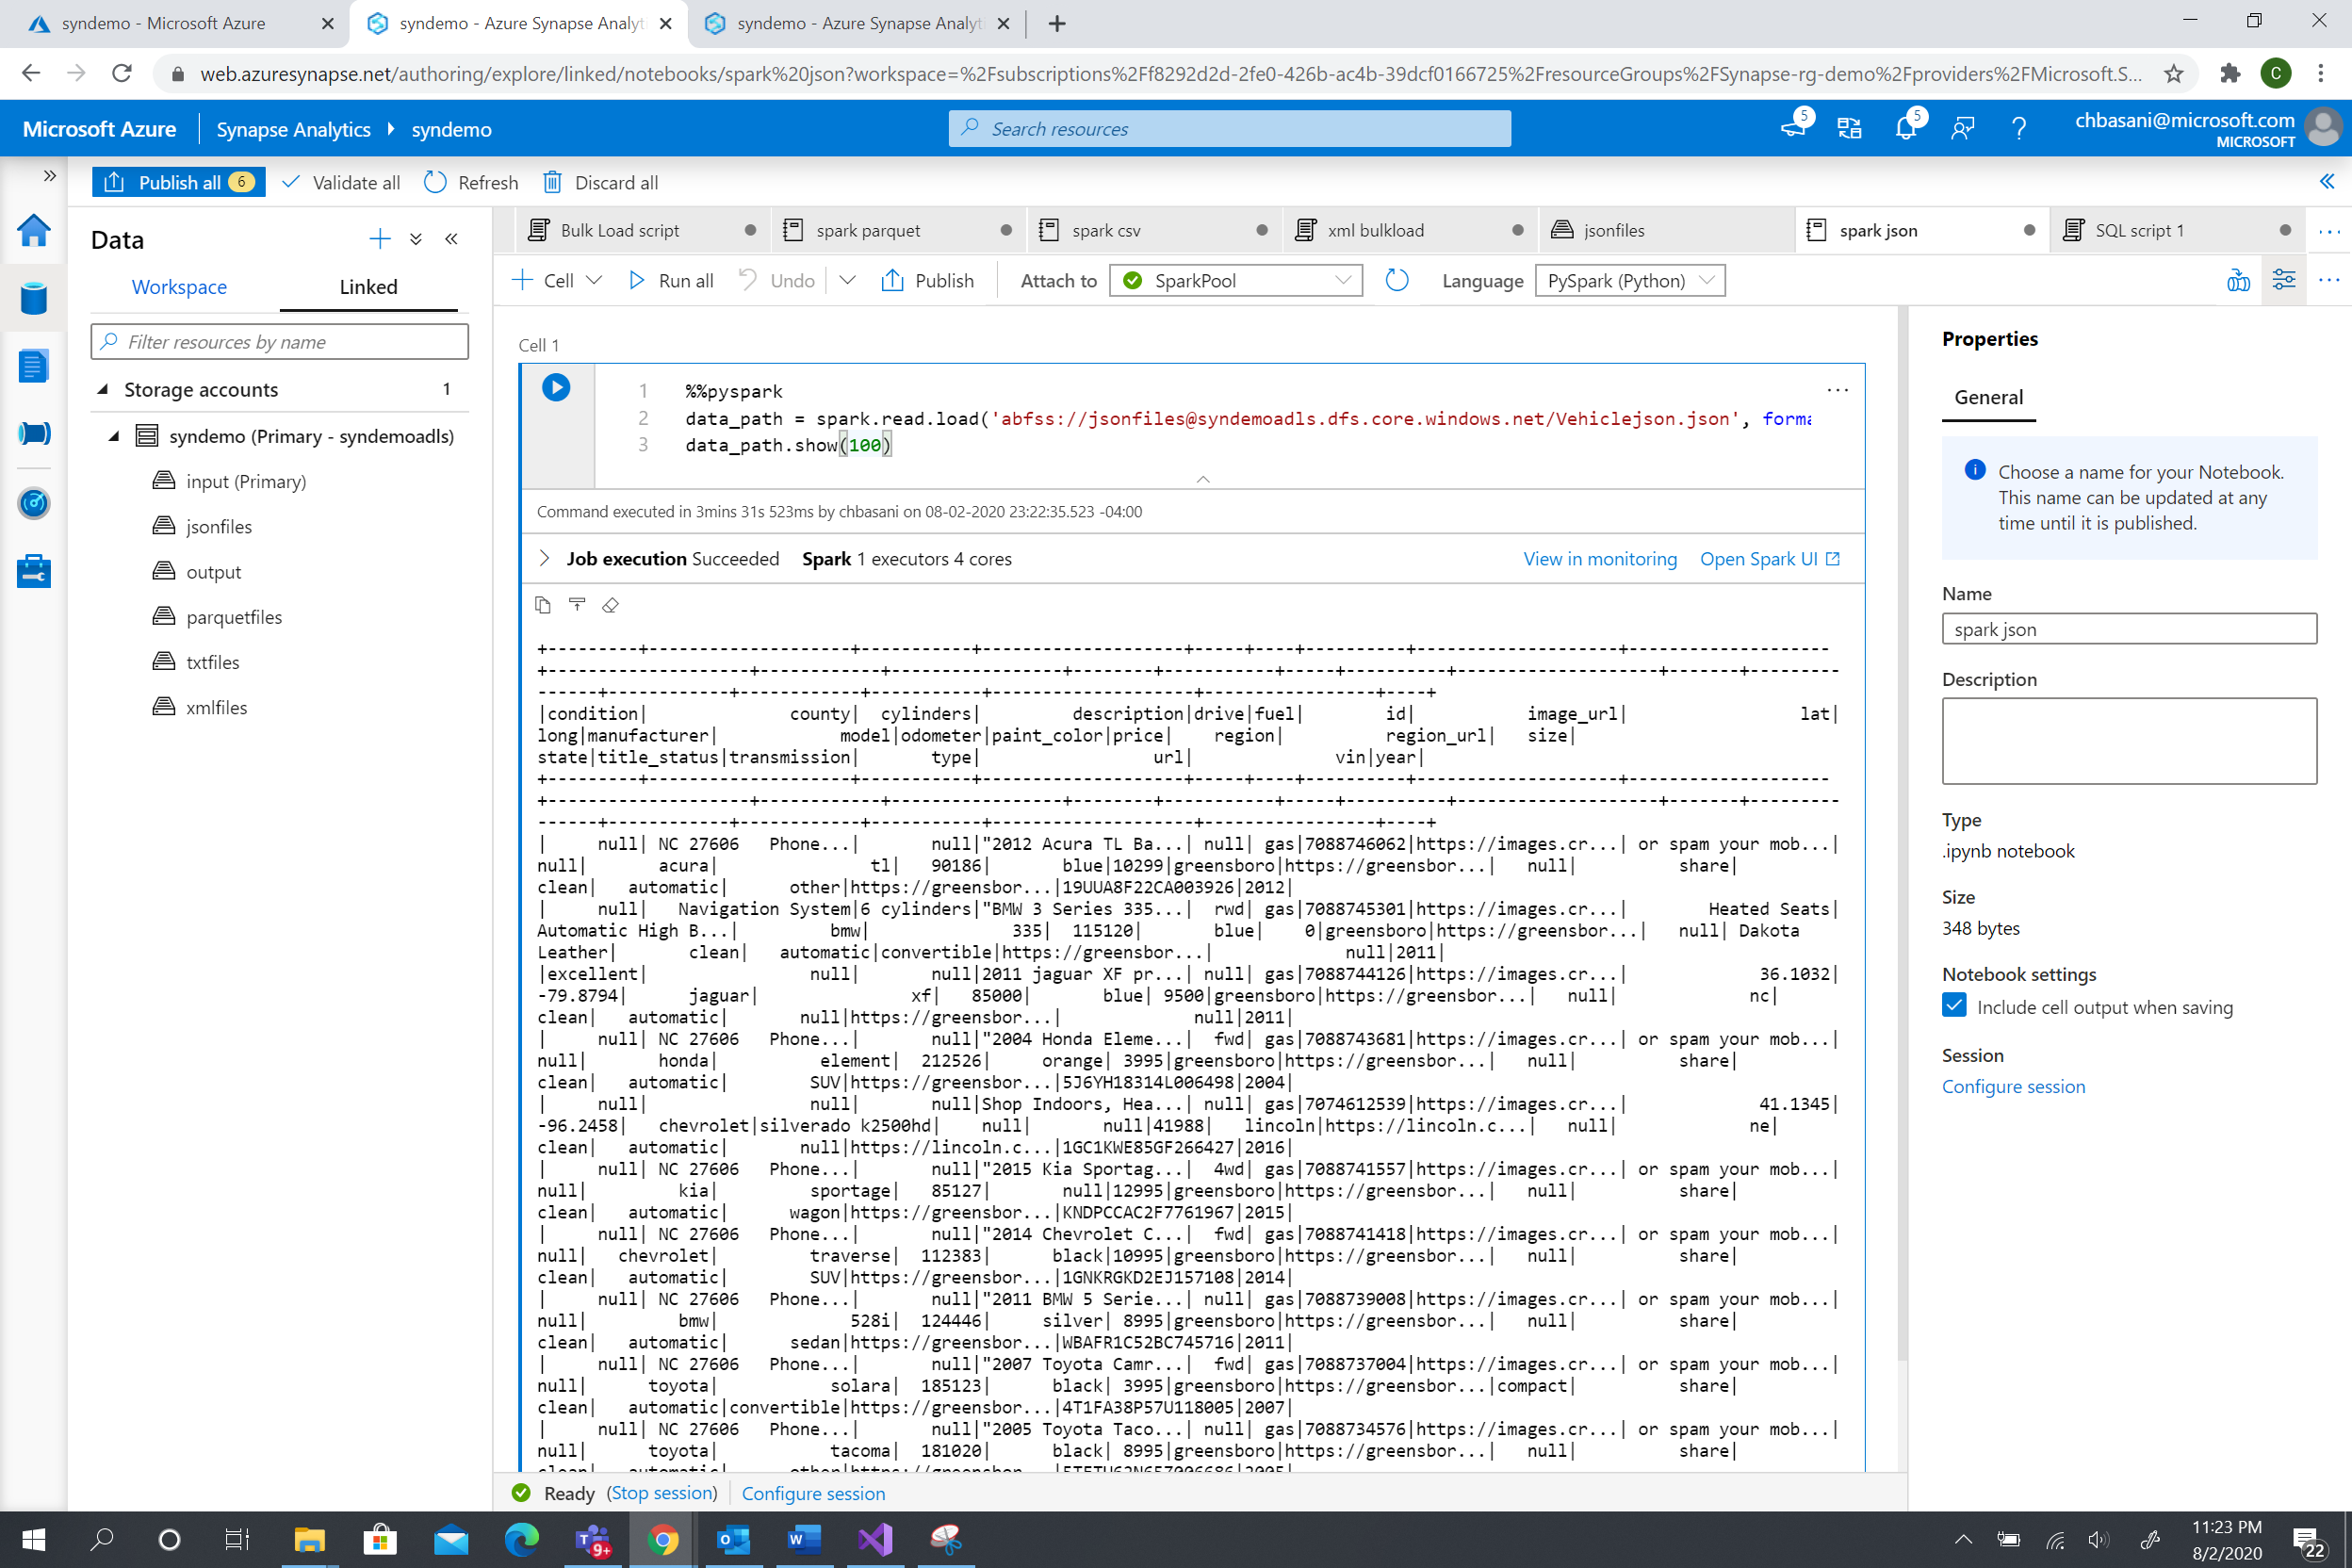
2. For XML bulk load --- Not the correct schema detect

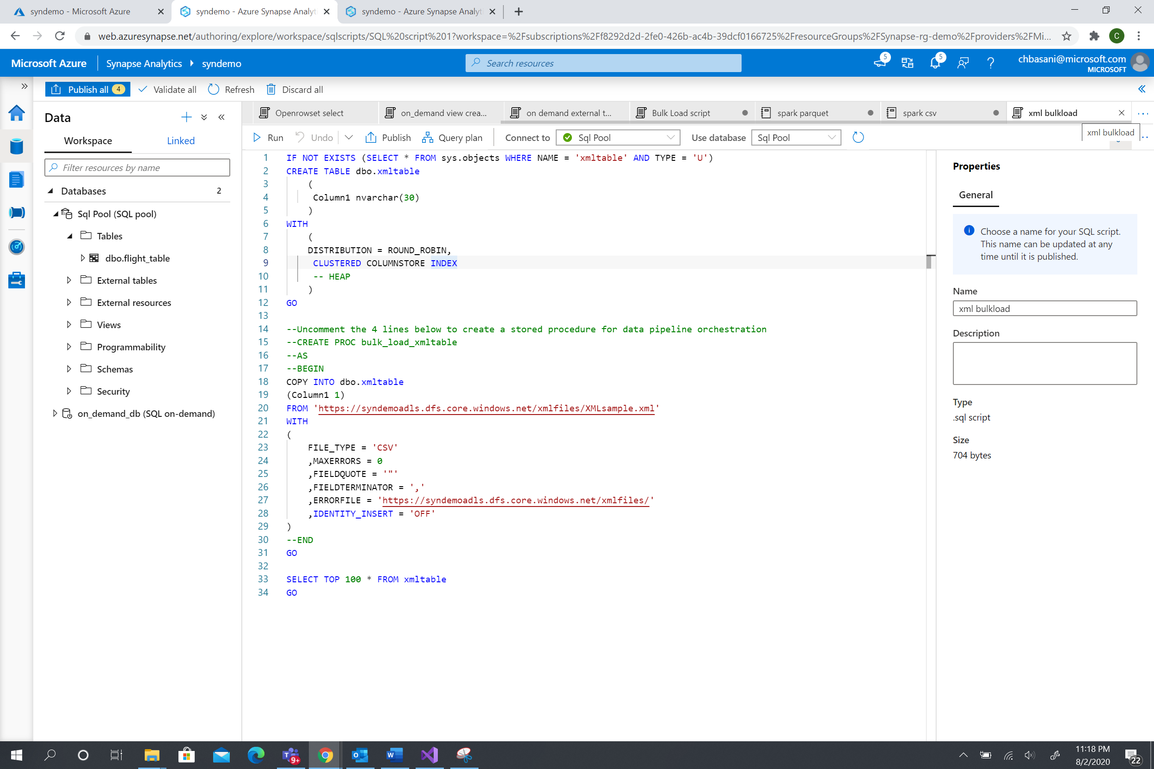

1. Read SQL data :

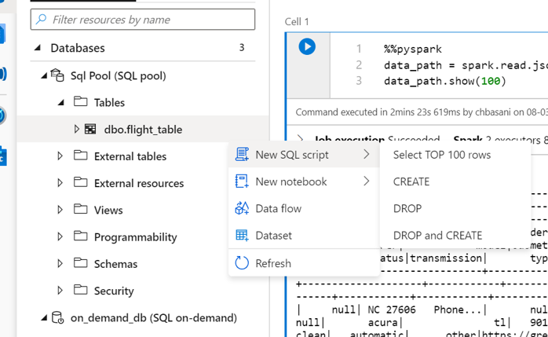

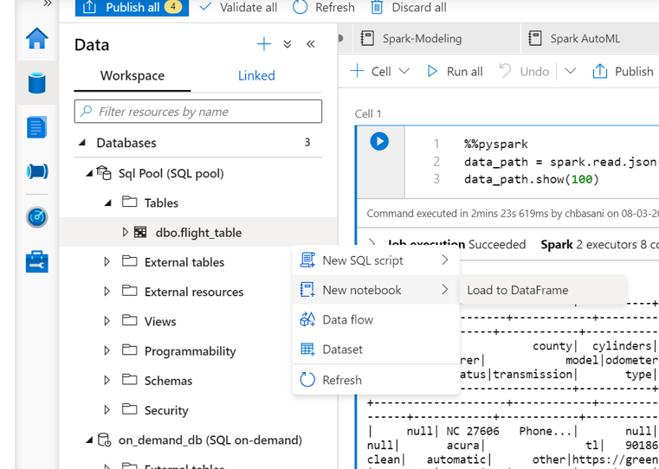

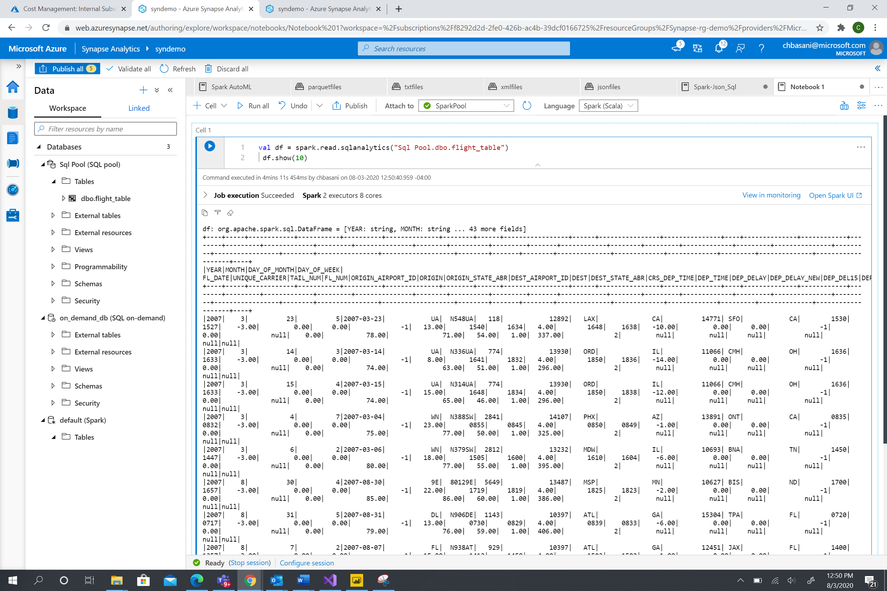

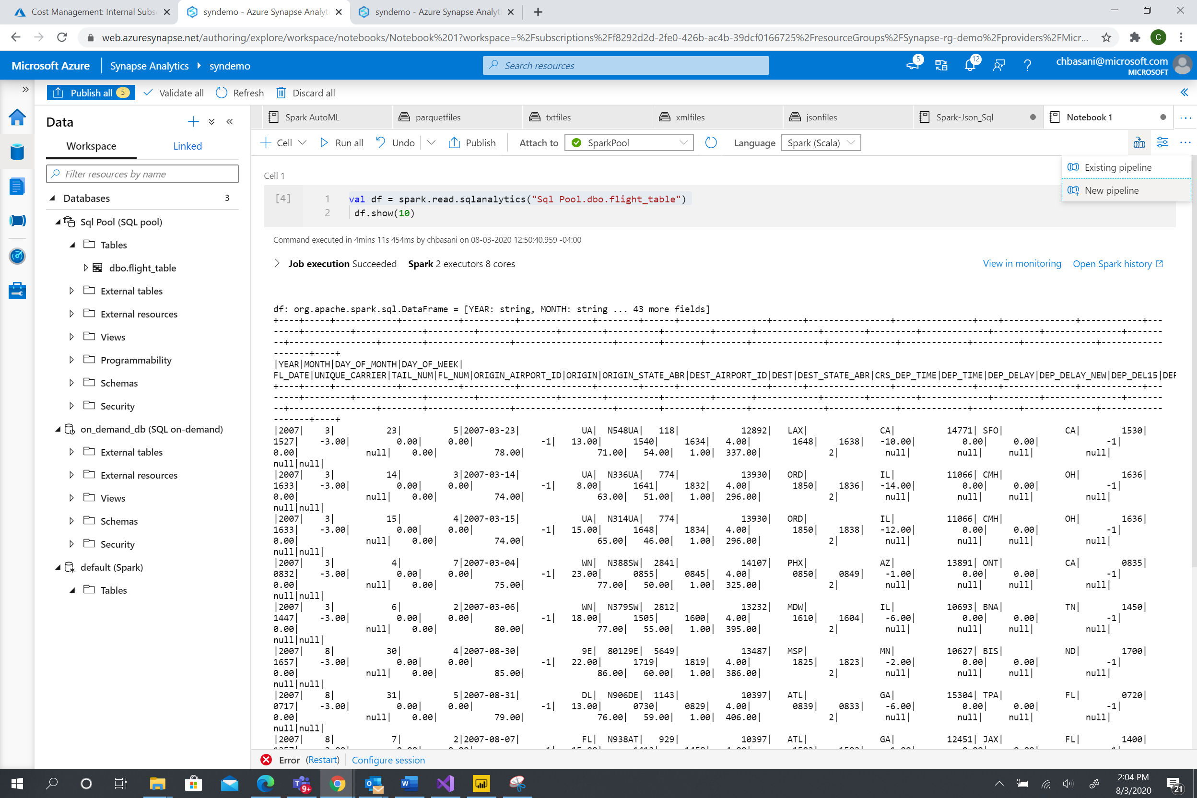

Try the additional Spark codes in the script folder for spark -sql process.



Spark Modeling: . Import the code to the spark environment

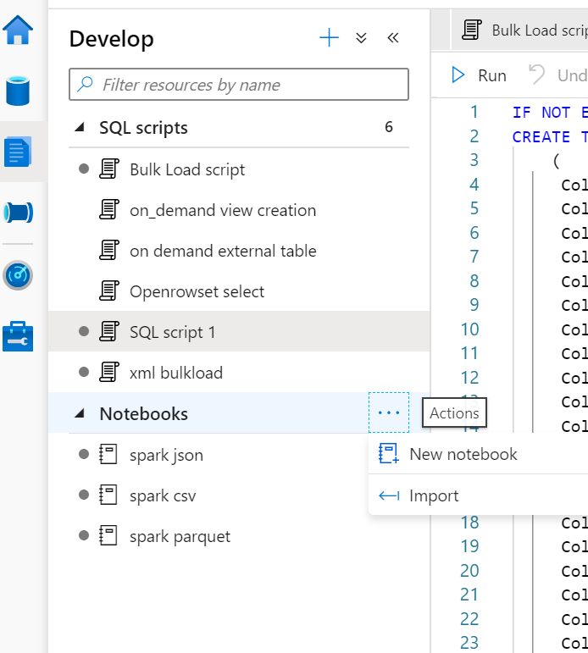

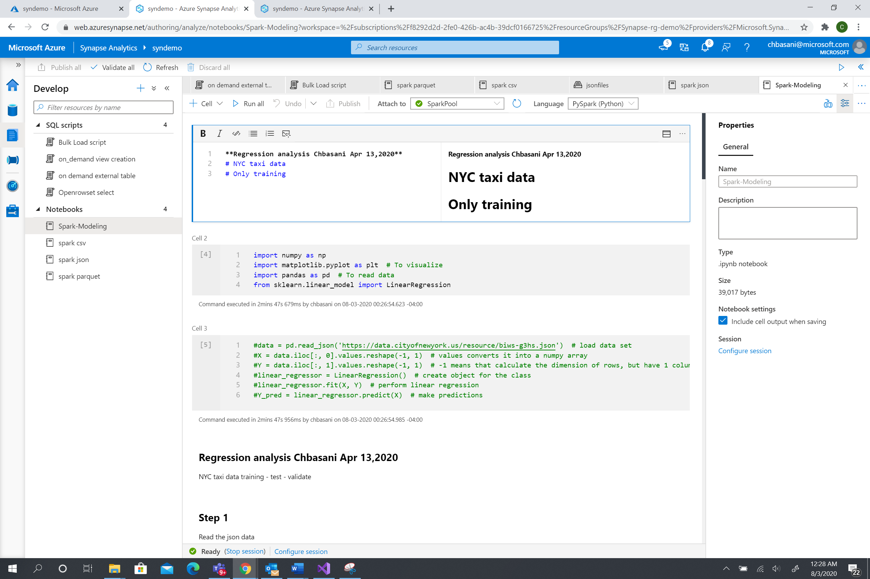

“Run all “ to execute the script.

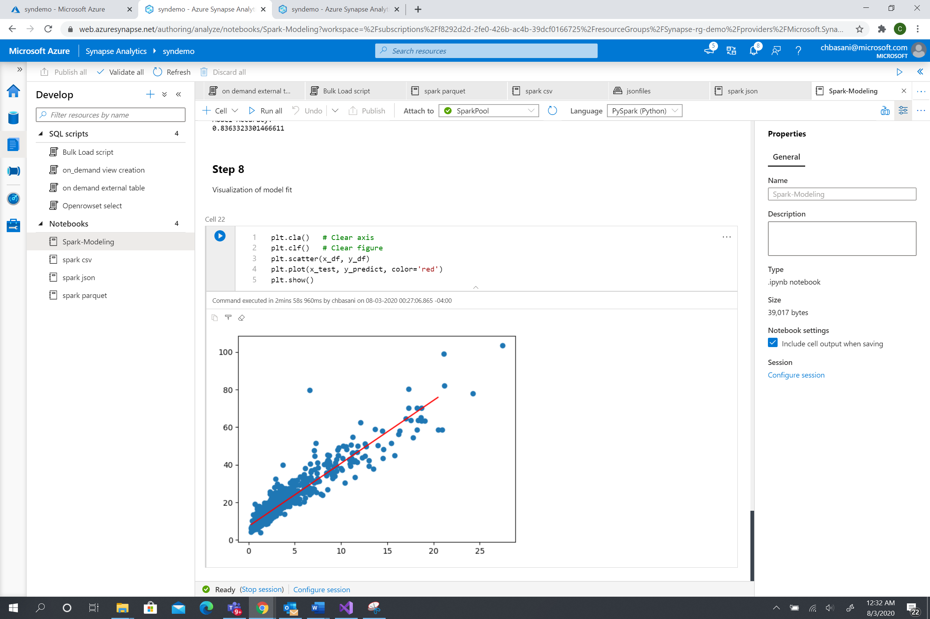

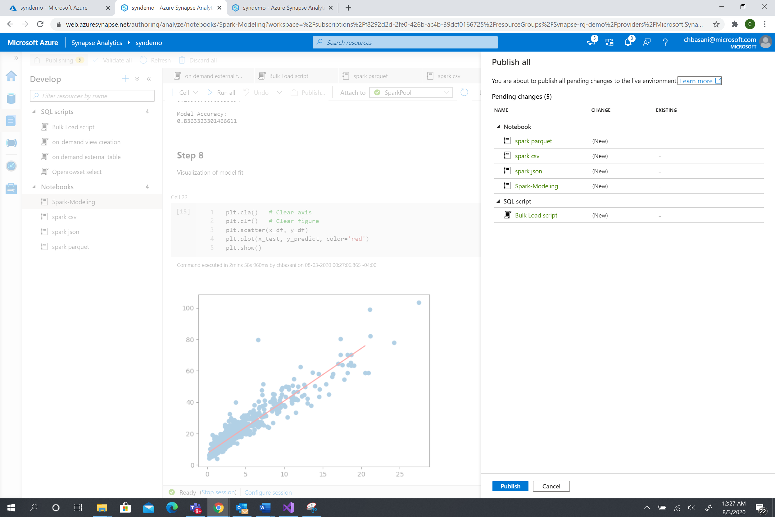

Publish the codes to Workspace.

Spark - AutoML code:Import the code.

1. Create a ML workspace.

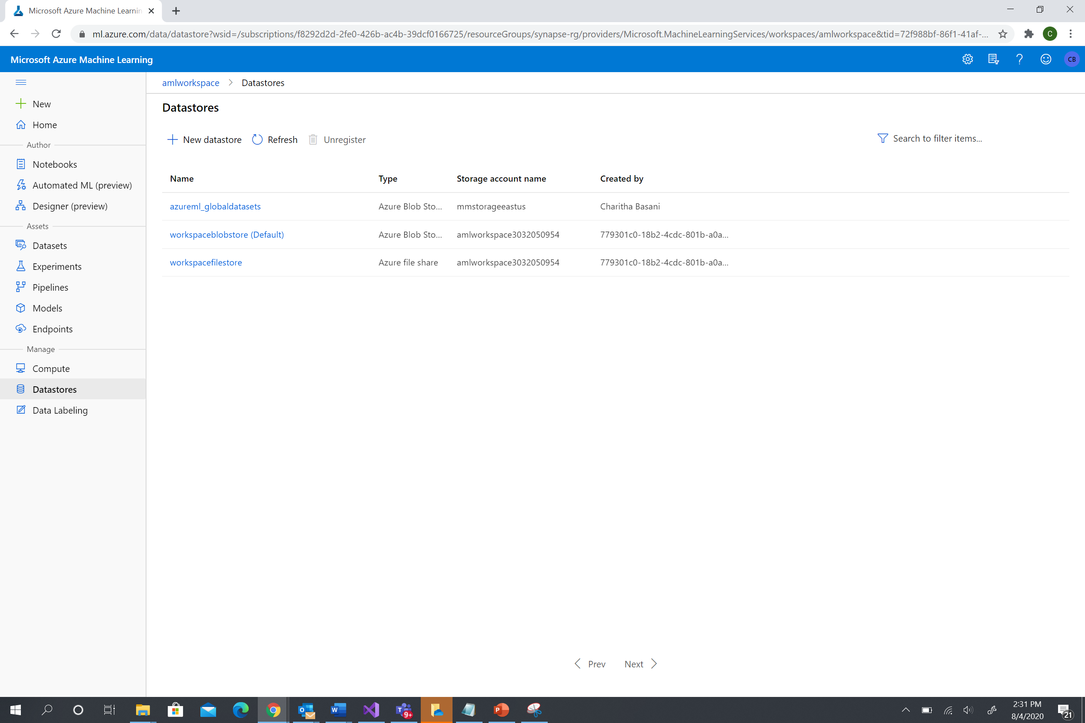

1. Connect to the AutoML workspace from Synapse. 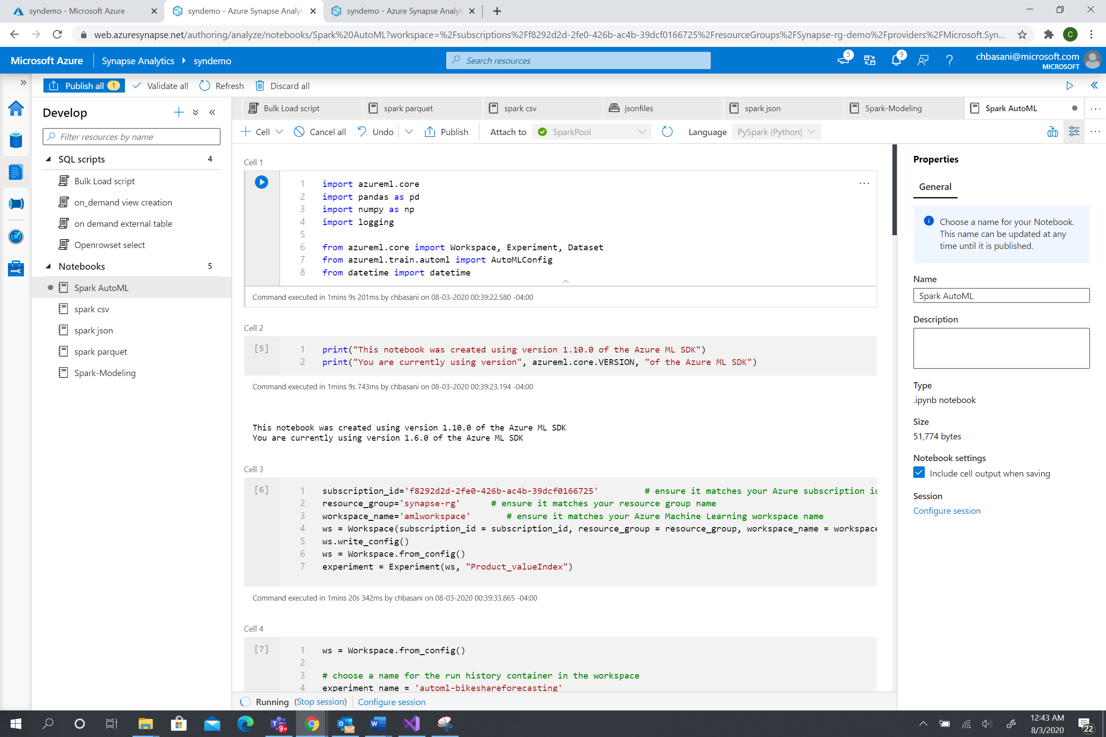

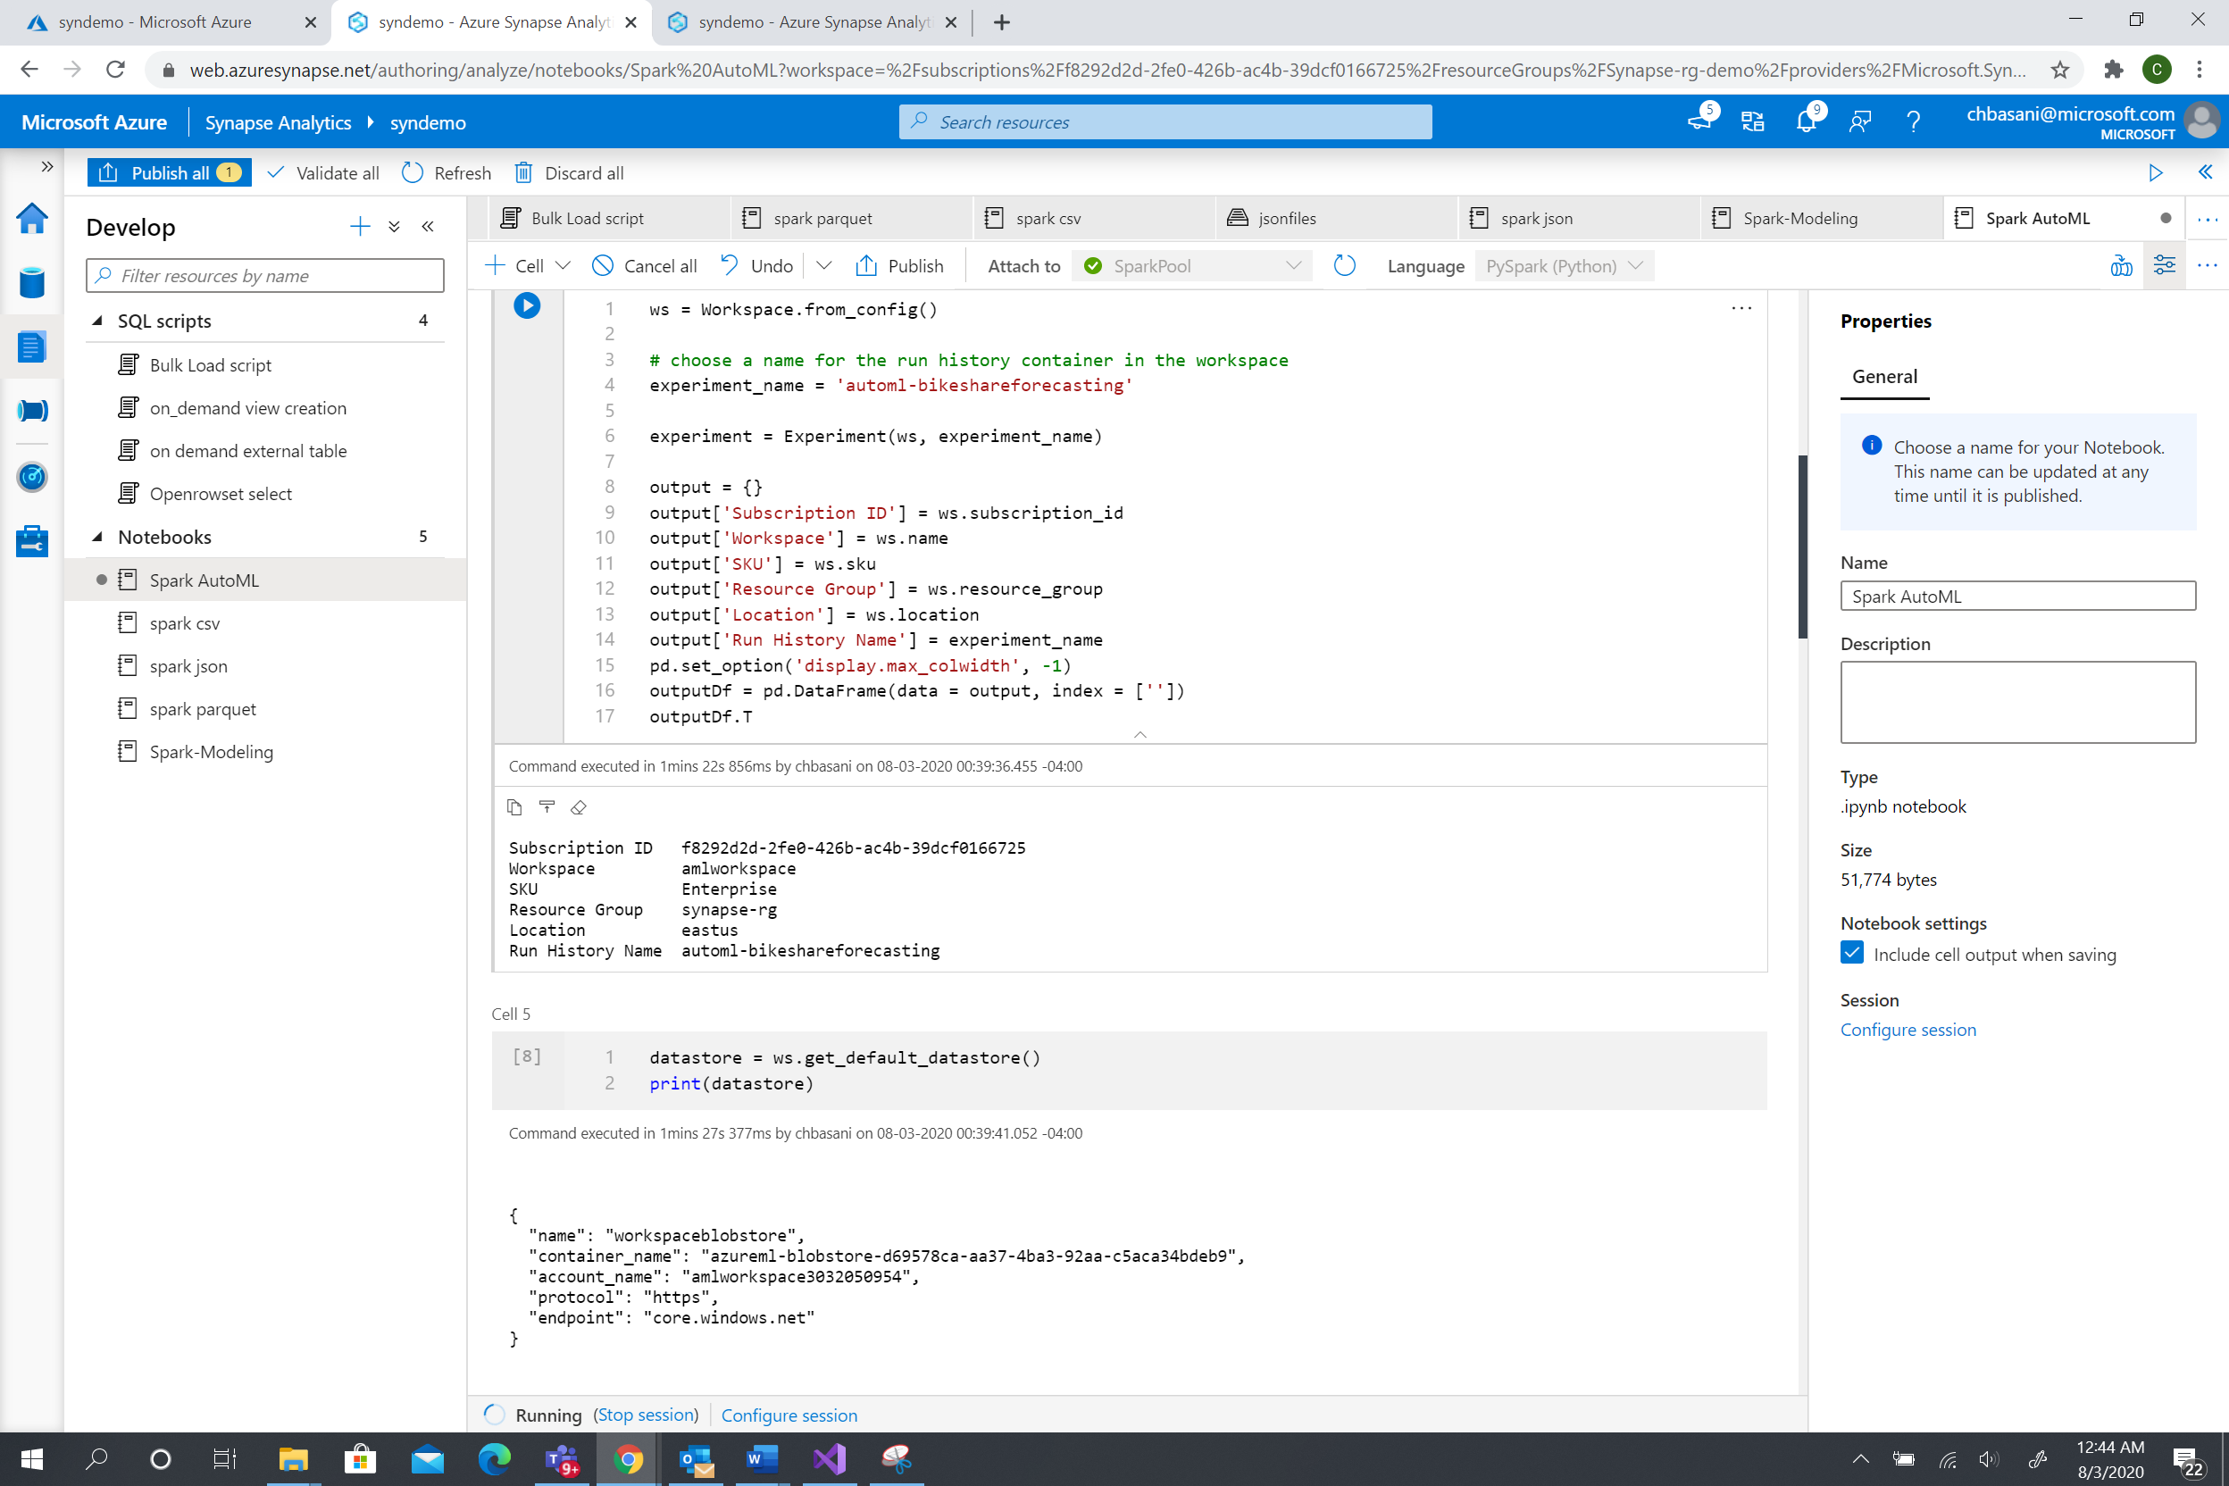

1. Create a cluster or connect to the needed cluster. 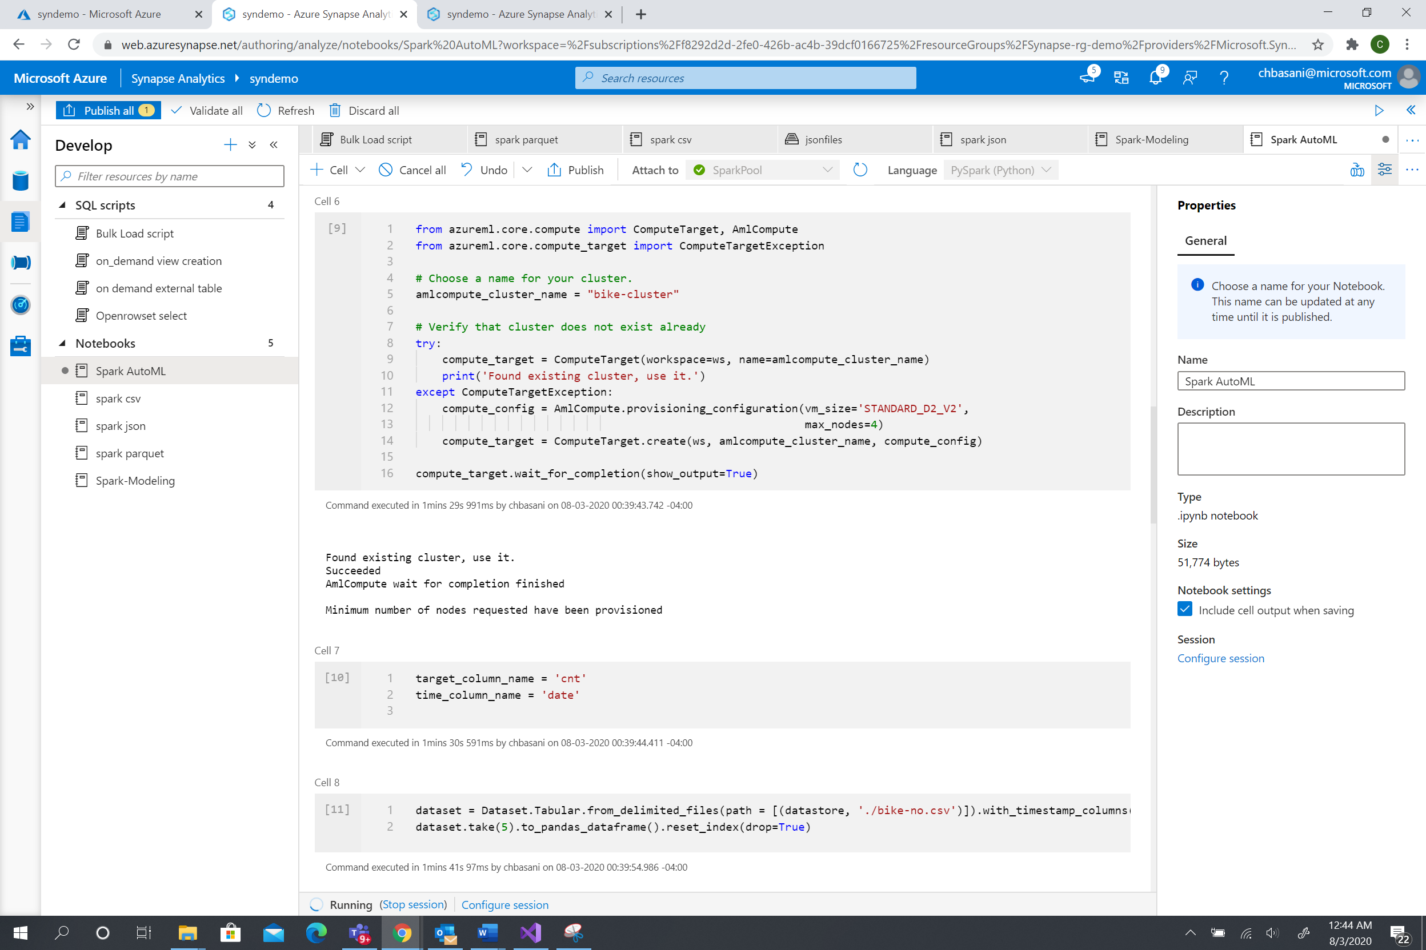

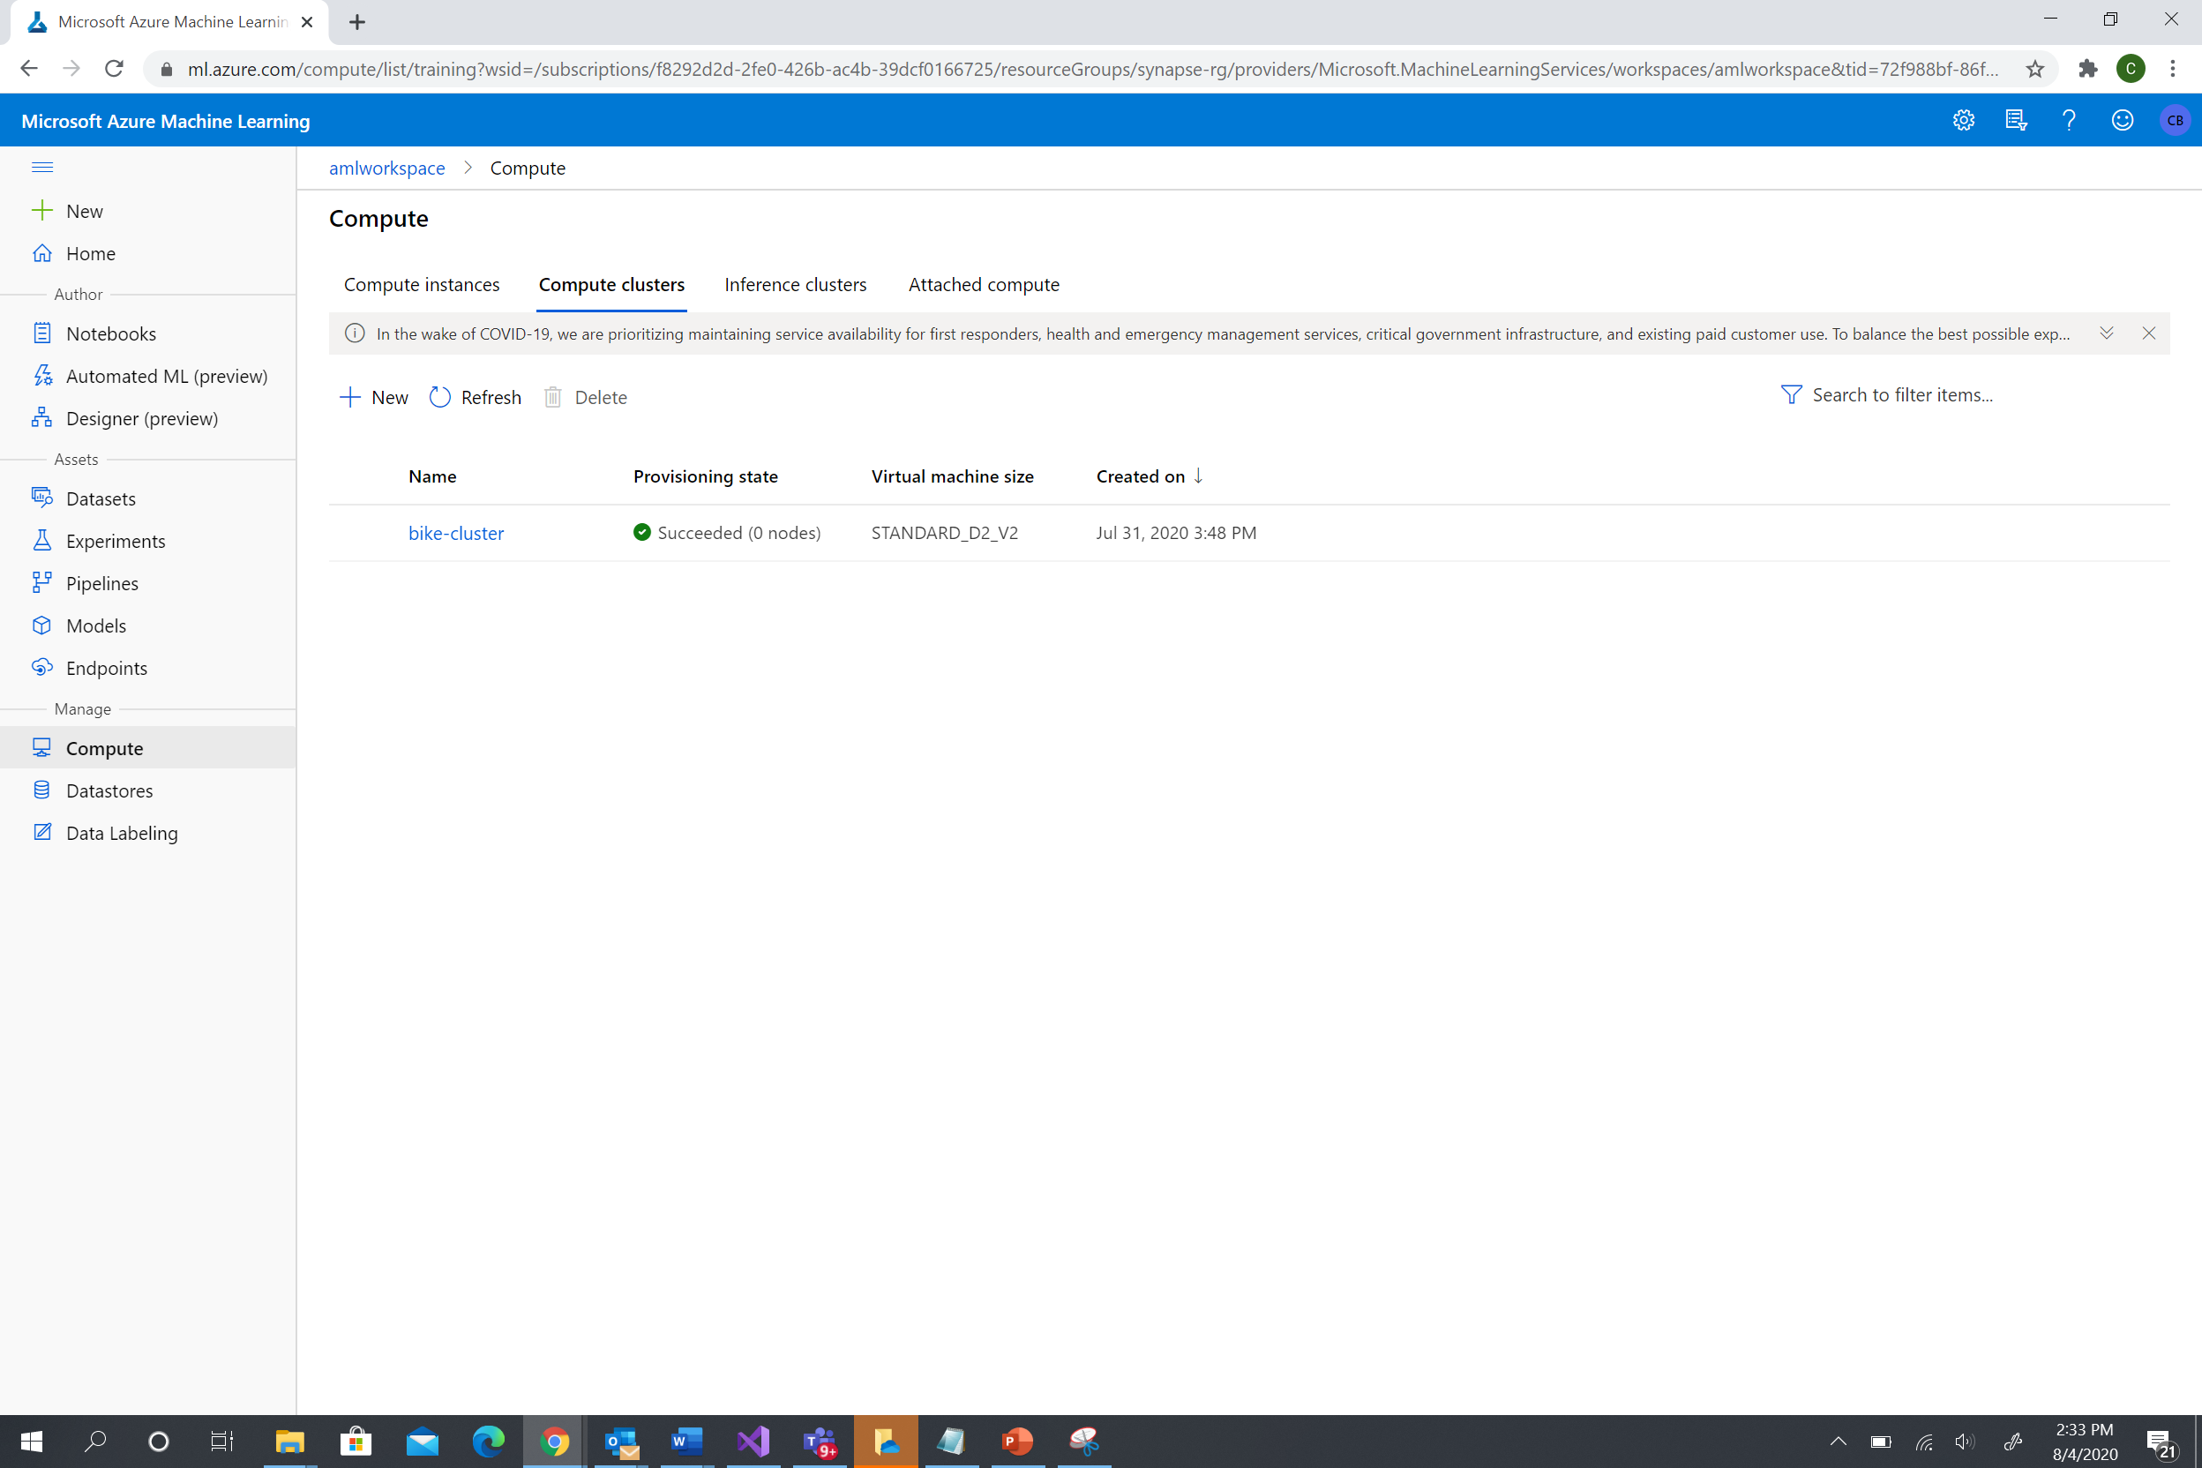

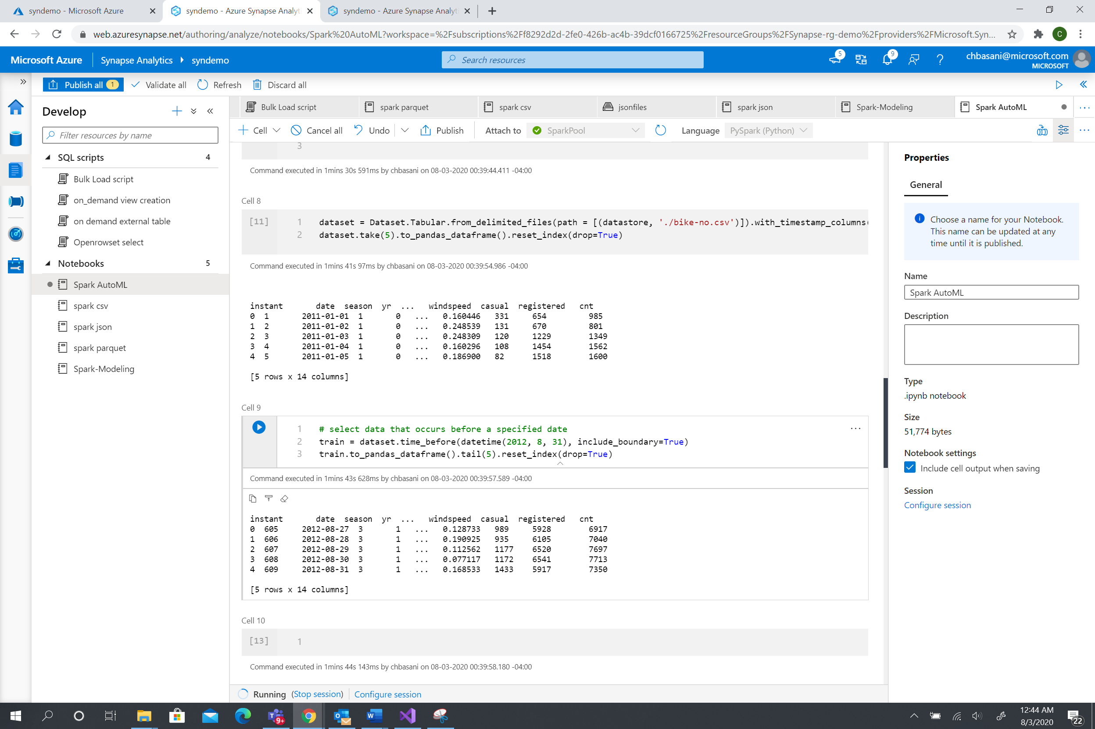

Browse through the AutoML workspace , for data store, clusters, experiments. 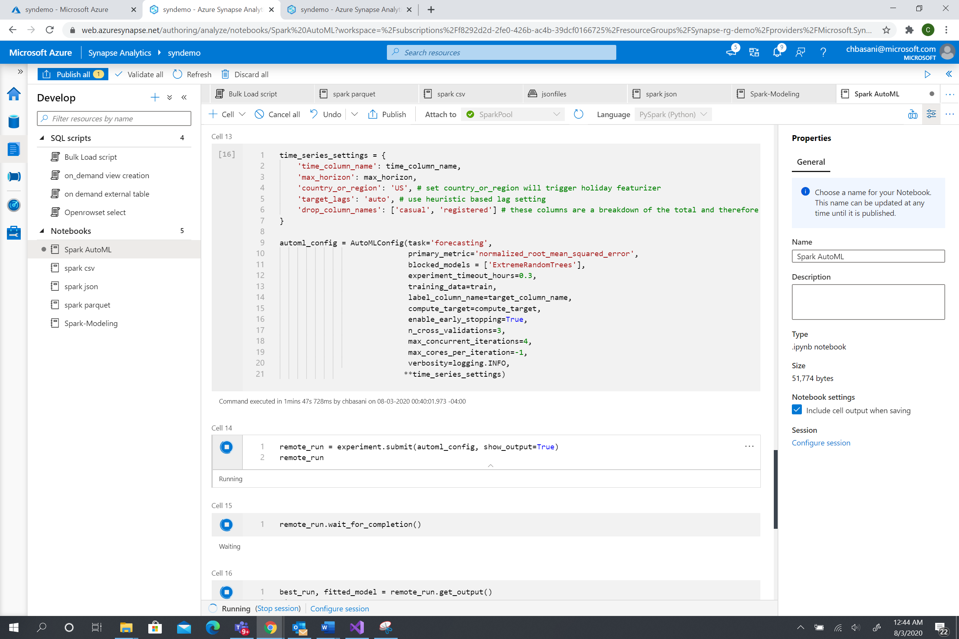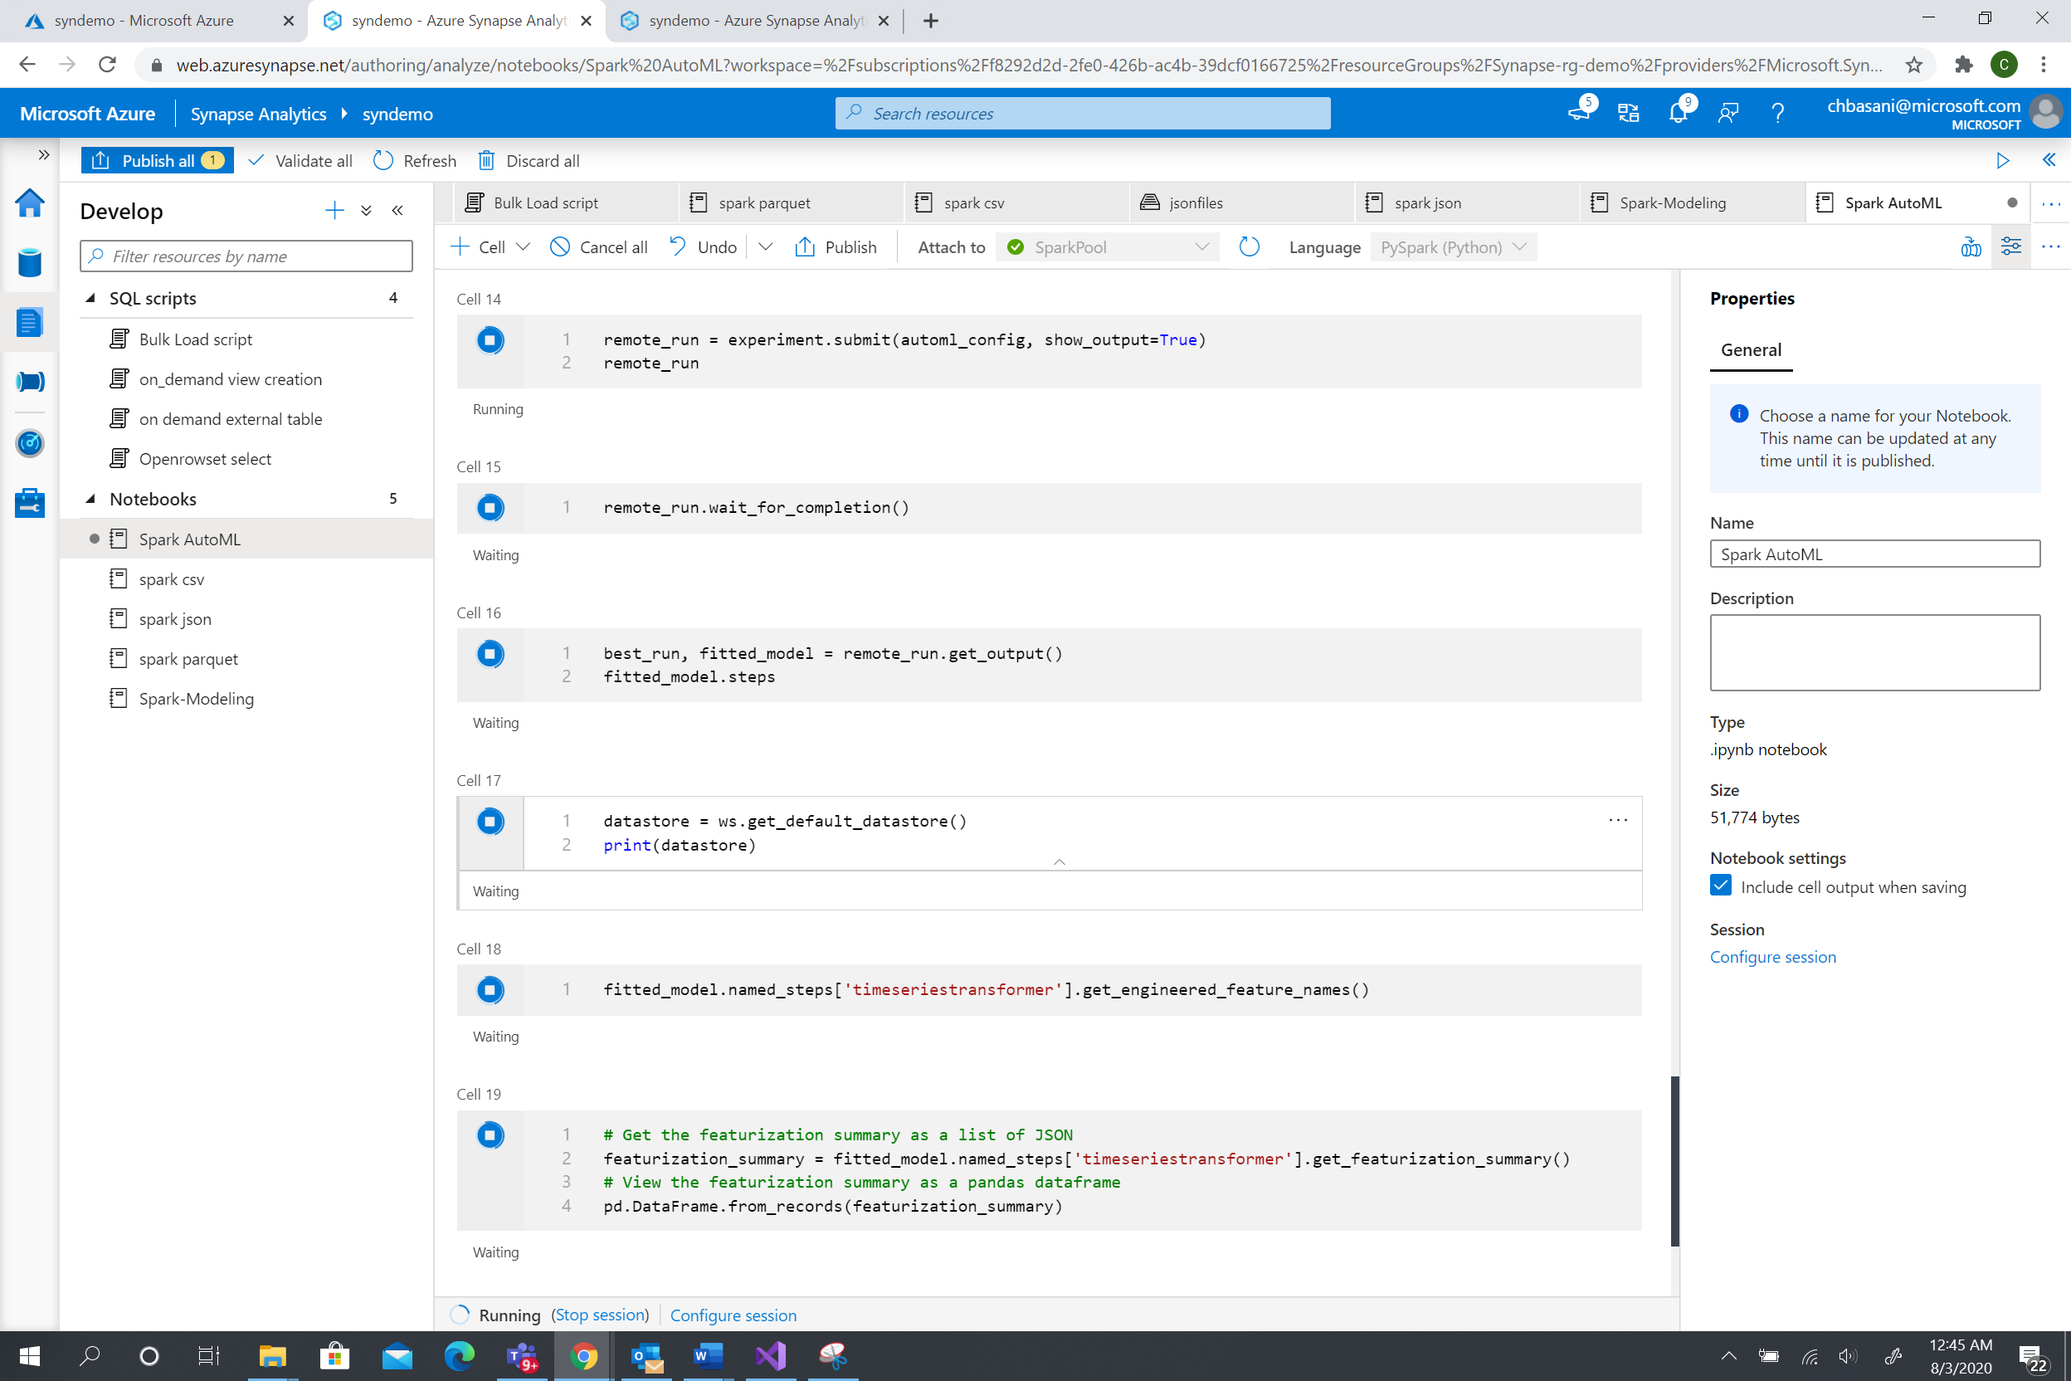

1. Run the AutoML on the remote cluster. 